

Ecological factors in disease emergence from animal reservoir.

Marius Gilbert  Free University of Brussels, CP 160/12  50, av. F.D. Roosevelt  B-1050 Brussels BELGIUM  E-mail: mgilbert@ulb.ac.be | William Wint  Environmental Research Group Oxford  P.O. Box 346  Oxford, OX1 3QE  UNITED KINGDOM  william.wint@zoo.ox.ac.uk | Jan Slingenbergh  Animal Health Service,  FAO  Viale delle Termi di Caracalla  00100 Rome  ITALY  jan.slingenbergh@fao.org

April 2004
Terms of Reference

Under the overall guidance of the Chief, Animal Health Service and in direct collaboration with AGA staff involved in epidemiological implications of the structural dynamics of the monogastric livestock sub-sector in East Asia, contribute to the analysis of ecological factors in disease emergence from livestock reservoir.

In particular, the incumbent will:

- Establish in a GIS environment, quantitative measures of epidemiological instability as ensuing ecological change:
  - Monogastric Livestock. Indicators for (in-) stability here include biomass/density, Farmer Population density, O/I or sterility index, plus some indicators for the availability of physical infrastructure to be obtained from GDP per capita x people density and, also, the density of roads.
  - Globalisation. Indicators to comprise international trade volumes of live animals and their products and, at the subnational level, the meat production-demand discrepancies for animal movement related to trade.
  - Urbanisation of livestock. Here, indicators may simply comprise the stats, for different years, on the coinciding distribution of animals and people.
  - Climate change (plus related floods/droughts) (to the extent feasible/practical) indicators are perhaps the OIE data against the current and future LGP spectrum, and changes in vector distribution and abundance (georeferenced molecular data on strains and insect sub-spp; as available)
  - Veterinary services. Indicators to comprise VPH/AH investment against the revenues from animal protein production, for different points in time (applying the Protein income density map of the world).
  - Land and water management (to the extent feasible/practical). Indicators to comprise presence of game and forest reserves/wildlife resources/avian fauna; info on land plus water resoure use/management.
17 days

- Following the epidemic hotspots already identified for pig diseases in China, explore the factor potentially implicated in introduction (from animal reservoir) and transmission in the human population, of VPH pathogens. In particular, depict, at the local level, the process of ‘urbanisation’ and ‘structural’ changes of livestock production and food-chain, the presence of processing plants, waste disposal practices, markets and distribution chains.
- Undertake travel to FAO HQs, Rome, 8 to 10 March 2004 and Oxford, UK, 29 March to 3 April 2004 to participate in technical workshop on the definition of Ecological change in Disease Emergence from animal reservoirs;
- Follow-up the above workshops and contribute to the modelling of ecological changes; (2 x 7 days).
- Prepare and submit to FAO Rome a report on the above, in English, in hard copy (x3) plus a CD (x2) before end April 2004.

Acknowledgements

The author wish to thank the following people for their contribution to the present work, through most helpful discussions, or by providing critical data: Vincent Martin (FAO, AGAH), Fairouz Larfaoui (FAO, AGAH), Awatif Siddig (FAO, AGAH).
Table of contents

Introduction 5
Spatial and geographical patterns in output/input and agricultural population density. 9
Theoretical trajectories under an assumption of self-sufficiency 16
Output / input and agricultural population as predictors for annual status in poultry OIE list A diseases. 22
The 2004 HPAI outbreaks as study case to explore the association between poultry disease risk and output/input and agricultural population density. 26
AgPop distribution 26
Livestock distribution an productivity 27
HPAI outbreaks as a function of agricultural population and output/input 31
Conclusion 35
References 36
Appendix 37
I. List of countries considered in the analyses (FAO names) 37
II. Models of the proportion of agricultural population to the total population as a function of time for different continents, FAO regions and individual countries. 38
III. Trajectories of OI/AgPop in North-East and South-East Asia. 41

Introduction

Emerging diseases are defined as “Infectious diseases whose incidence in humans has increased in the past 2 decades or threatens to increase in the near future” (CDC 2004). This includes diseases which have been known in the past and simply expanding their incidence or range, and diseases that recently appeared in humans such as Severe Acute Respiratory Syndrome (SARS) or Acquired Immune Deficiency Syndrome (AIDS).
Schrag & Wiener (1995) argued that changes in pathogens and/or hosts ecology are primarily responsible for the majority of emerging diseases and that emerging disease caused by evolutionary changes alone are comparatively relatively rare. “Ecological changes” is a rather vague term, comprising very different processes under the same umbrella: changes in agricultural practices, urbanisation, climate change or globalisation (Schrag & Wiener 1995, Morse 1995). The true common feature of all these processes is that they largely result from changes caused by human activities. The title of Schrag & Wiener’s paper “Emerging infectious disease: what are the relative roles of ecology and evolution ?” could actually be substituted by “Emerging infectious disease: what are the relative roles of human activities and evolution” ? If one looks over a relatively short time-span, it seems that we are probably responsible for emerging diseases by creating and maintaining the conditions for existing pathogens to enter, persist and develop in new host populations (Dobson & Foufopoulos 2001). In this context, emerging diseases simply appear as a response to environmental changes caused by human activity.
The reason that most emerging diseases are reported to be related to ecological changes rather than evolution might just be a matter of time-scale: ecological change may have been the main factors influencing disease emergence over the last few decades because these changes have been fast, while evolution has played a major role in the emergence of diseases emerging over centuries (Diamond 2002). This does not, however, prevent evolution from playing a role in the short-term adaptations of pathogens to human. As nicely shown in Antia et al. (2003), pathogen strains entering into a new host population may initially have an overall reproductive number R₀ < 1 that leads to the pathogens’ extinction, but prior to extinction, some may evolve and increase their virulence to give an R₀ > 1, allowing them to persisit and spread into a new host population. If emerging diseases are truly an evolutionary response to environmental changes, assessing the relative role of ecology and evolution is unwarranted as they are closely intertwined.
Another approach to understand disease emergence is to consider that it is basically the result of two sequential processes i) the adaptation of a pathogen to a new host, and ii) the development and spread into the new host population, which may occur because of changes of the pathogen’s virulence (Antia et al. 2003). Different questions relate to each of these processes.
How did a pathogen enter a human population? What are the characteristics of potentially invasive pathogens? These questions relate to the adaptation of a pathogen to a new host and the comparison between emerging diseases and invasive species helps to partly address them. Invasive alien species are defined as species introduced outside their natural, past or present, distribution (UN Convention on Biological Diversity, Decision VI/23). These species, generally introduced by human activities, have adverse effects on indigenous fauna and are now considered as the second most important cause of the global biodiversity crisis (Vitousek et al. 1997) and recognized as a clear threat to ecosystems, habitats or species, with severe economic and environmental consequences (UN Convention on Biological Diversity, Decision VI/23). Questions about emerging diseases and invasive species essentially address how an organism adapts to a new environment and spreads (May 2001). In biological invasion ecology, it has long been recognised that successful invaders are generally species able to maximise thier fitness in changing environments, i.e. r-strategists such as weeds in invasive plants (as opposed to grown trees), or generalist predators or herbivores in invasive animals (as opposed to specific predators or herbivores). Although is was not expressed in such terms, emerging diseases pathogens are recognised to follow approximately the same pattern (Cleaveland et al. 2001), i.e. most successful emerging pathogens are RNA viruses (r-strategists, that are small, with a short generation time, and for which minor changes in the genome may change host-specificity), whereas helminths are considered as unlikely candidates to jump host-species barriers (K-strategists, with longer generation times, and higher host-specificity). The question of the origin pathogens new to humans, although interesting, will not be addressed here, firstly because truly new pathogens are relatively rare in humans, and secondly because the primary focus of this work is emerging diseases of livestock.
The second process, i.e. disease spread in the new host population, will determine the success of an emerging pathogen in the newly invaded host. Factors facilitating the spread into the new population are not specific to emerging diseases and apply equally to any epidemic disease. As developed in May et al. (2001), the spread mainly depends on the overall reproductive number being higher than 1, which is subject to change as consequence of both a better adaptation to the host, and changes in the spatial structure of the host population (e.g. changes in the geography of human population may have contributed to drive the R₀ above 1 in the emergence of AIDS in Africa; May et al. 2001; see also Keeling 1999). Standard epidemiological models predict that the size of epidemics relates to the size of the susceptible population. If we think of the susceptible population as a network of susceptible hosts, then this general statement can be refined by taking into account the spatial structure of social groups (Keeling 2001). For diseases with lifelong immunity, local extinctions of the diseases are observed, and one may consider a network where each node is a group of hosts, i.e. village or city, and use the analogy with metapopulation to explore diseases spatial dynamics (Grenfell & Harwood 1997). If the size of the epidemics is closely related to the size of the susceptible hosts, using the metapopulation analogy, it is also related to the size of the host metapopulation. In this case, the main prevention methods consist of reducing the size of the host metapopulation, mainly by isolating some groups of animals from the infection, as isolated hosts are not part of overall host metapopulation, and so the metapopulation size is reduced. In a given landscape for a given disease affecting a host species, the risk of epidemics can be assessed against the size and structure of the host metapopulation, and the level of isolation of each sub-population.

A significant difference between human populations and livestock, and monogastric livestock in particular is that herd size is easily controlled, animals can be confined within a given area, and can even be permanently isolated from the outside world . As a direct consequence, the type of husbandry (from extensive low-input/low-output systems where animals are raised in the open air, to industrial high-input/high-output production units where animals are raised within highly biosecure units) heavily influences the susceptibility to infection. If we generalise this to encompass different diseases and transmission pathways, the risk of epidemic can be viewed as a function of four main factors: production intensification (as a measure of local biosecurity level and animal health investments); production spatial structure (size and structure of the host metapopulation, which forms the “static environment in which disease spread is taking place”); the transmission pathways (trade of live animals, of meat products, marketing and distribution); and finally the pathogen’s innate ecological characteristics (virulence, host-range, infective period, vector distribution, reproductive strategy). Most of the factors which have been cited in the literature to contribute to the emergence of livestock diseases can be assigned to these four factors (Table 1).

Table 1 Relationship between factors frequently related to livestock diseases epidemiology and four main factors determining disease risk.

Husbandry¹ Metapopulation² Pathway³ Pathogen⁴

Human Demography x x x
Technological progress x x
Land pressure x
Livestock density and distribution x
Animal movements x
Urbanisation of people x
Peri-urbanisation of livestock x
Active disease control x
Wildlife contacts x x
Farming systems x
Agro-Ecological zones x x
Dietary habits x
Waste management x x
Hobby / cultural animals x
Vector distribution abundance x
Infrastructure x
Seasonality of livestock management x
Population structure (age, sex, etc.) x
Phylogeography:
- Pathogens x
- Animals x
Globalisation:
- People x
- Trade x
Climate change:
- Primary production x x
- Vector distribution x
- Migration patterns x
- Pathogen survival x
- Distribution of rural people x

¹ Factors allowing an increase in the productivity from extensive to industrial production systems, such as biosecurity, high-production animal breeds, multiple stage systems, genetics, quality of feeds. ² "Static" environment in which the spread is taking place, the range within which microbial traffic takes place: distribution of holdings, clumping, extensive-intensive contacts, spatial structure of production units. ³ Possible flow of pathogen through the production or food chain, infection pathways: Feed – live animals – processing – marketing & distribution - international and subnational trade - short-distance movements. ⁴ Factors relating to the pathogen innate biology: reproductive (r/K) strategy, host range, mode of transmission, virulence, infective period, vector distribution.

Among these four main factors, the production intensification and the production spatial structure can be viewed as relatively independent on the disease (all pathogens responsible for epidemics will develop better in open production systems that support a large metapopulation of susceptible hosts), whereas pathways and biological characteristics are disease-specific. Therefore, estimates of the level of production intensification and of the size of the host metapopulation should be able to be used to define the general risk of epidemics.

In a previous work (Gilbert 2003), the risk of OIE list A diseases of pigs & poultry was tested at the country scale worldwide against two surrogate measures of these factors: the production output/input (kg of meat produced per year and per animal, abbreviated as OI in the rest of this report) as measure of intensification, and the density of agricultural population (abbreviated as AgPop ) as a measure of the density of the host metapopulation. The current study refines this exploratory work by:
i) looking in more detail at the spatial and geographical patterns of OI and AgPop, ii) looking at the intrinsic association between OI and AgPop under an assumption of food self-sufficiency,
iii) exploring in more detail the association between OI, AgPop and OIE poultry disease status,
iv) testing the OI, AgPop risk assessment approach to the specific outbreak of highly pathogen avian influenza (HPAI) in East-Asia.

The report is largely focused on East-Asia, both because of the recent outbreak of HPAI, but also because of the very specific risk setting that is observed in this area as illustrated in the following chapters.

Spatial and geographical patterns in output/input and agricultural population density.

As intensification and farming levels vary both spatially and over time, we aimed to assess the historical trajectories of the two axes of OI of monogastric animals production (chickens and pigs) and AgPop in different geographical areas. The following variables were extracted from FAOSTAT at the country level for the period 1961-2001: chicken numbers, chicken meat production, pig numbers, pig meat production, total human population, agricultural population (AgPop), land area and arable land area. These variables were extracted for a list of 145 main countries (Appendix I) and used to estimate annual Output/Input of chicken and pig production (kg /year /animal), and AgPop density expressed as agricultural population per square km of arable land. The data were grouped according to three different classifications:

- industrial development. Industrial, Developing, Transition;

- Continent. Australia, North-America, Europe, South-America, Caribbean, Africa, Asia;

- FAO regions (Bruisma 2003). Eastern Europe, European Union, Com. Ind. States, Near East & North Africa, Industrial Other, East Asia, Baltic States, Latin America, North-America, Oceania, Sub-Saharian Africa, South-Asia.

As this report largely focused on East-Asia, the individual trajectories of the following countries were also identified: Cambodia, China, Indonesia, Japan, Laos, North Korea, South Korea, Malaysia, Mongolia, Myanmar, Philippines, Thailand, and Vietnam.
In addition to the trajectories representing the distribution of geographical areas along the OI/AgPop dimensions, it seemed useful to depict the future evolution of these trajectories according to predictions on livestock and production provided in FAO 2015/2030 (Bruisma 2003). Livestock and production figures for chickens and pigs were directly extracted from FAO 2015/2030. Predictions of human population to 2030 were available from FAOSTAT, but for AgPop to 2010 only. We therefore used past data on the proportion of agricultural people over the total population (1961-2001; and 2010), and modelled this proportion as a function of time for each continent, FAO region,individual countries and class of industrial development. An example is presented in Fig.1, and models used for other continents, FAO regions and individual countries are presented in Appendix II. All trajectories are presented in Figures 1.2 to 1.9.

. The first and most obvious observation is the marked difference between industrial, developing and transition countries (Fig. 1.2 & 1.6). Very little change in agricultural population is observed in industrial countries and a sharp rise in productivity is observed over the last 40 years. In the same period, developing countries show very little increase in productivity, and a very significant increase in the agricultural people density, mostly as consequence of generally rising population levels.

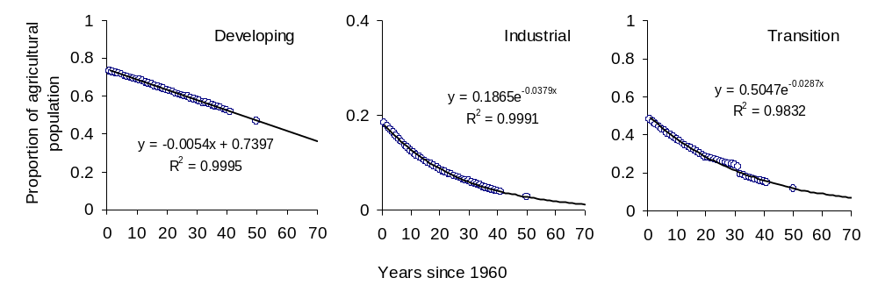
Fig. 1.1 Models of the proportion of agricultural population to the total population as a function of time for developing, industrial and transition countries.

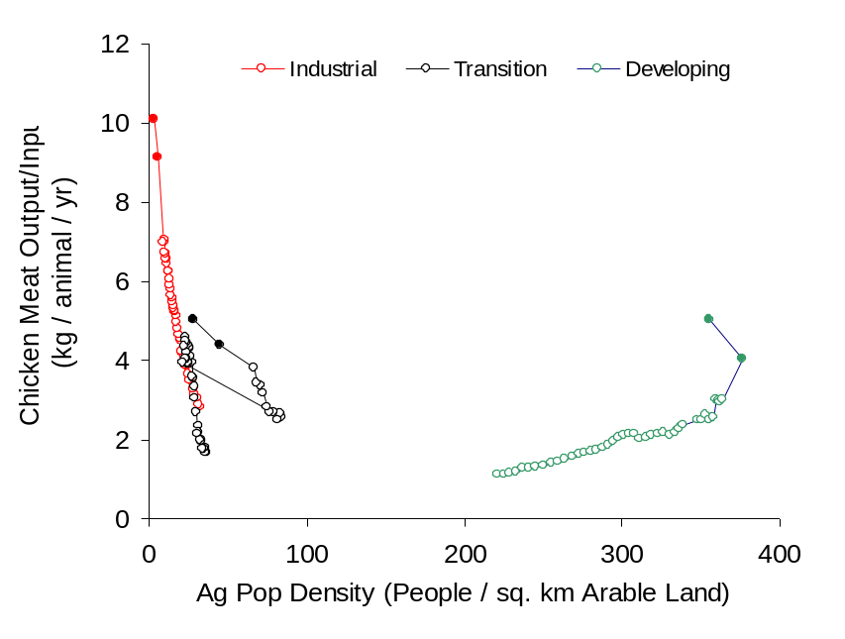
Fig. 1.2 Change in chicken meat output/input and agricultural population density grouped by industrialization level between 1961 and 2001 (empty circles) and predicted for 2015 and 2030 (full circles).

The same patterns are evident for the different continents (Fig. 1.3 & 1.7). North-America and Australia have a low and stable AgPop density, and have increased their productivity; Europe and South-America have reduced both their AgPop and the levels of intensification; and in Asia and Africa there has been a very significant increase in AgPop density with a relatively low productivity increase (although the increase in productivity in Asia is higher than in Africa). The plots grouped by FAO regions (Figs. 1.4 & 1.8) demsonstrate that sub-saharian Africa and South-Asia have similar types of trajectories mostly characterised by extensive production systems, little productivity gains, and an increasing AgPop density, whereas East-Asia supports a higher density of AgPop and generally higher productivity, in particular of pig meat.
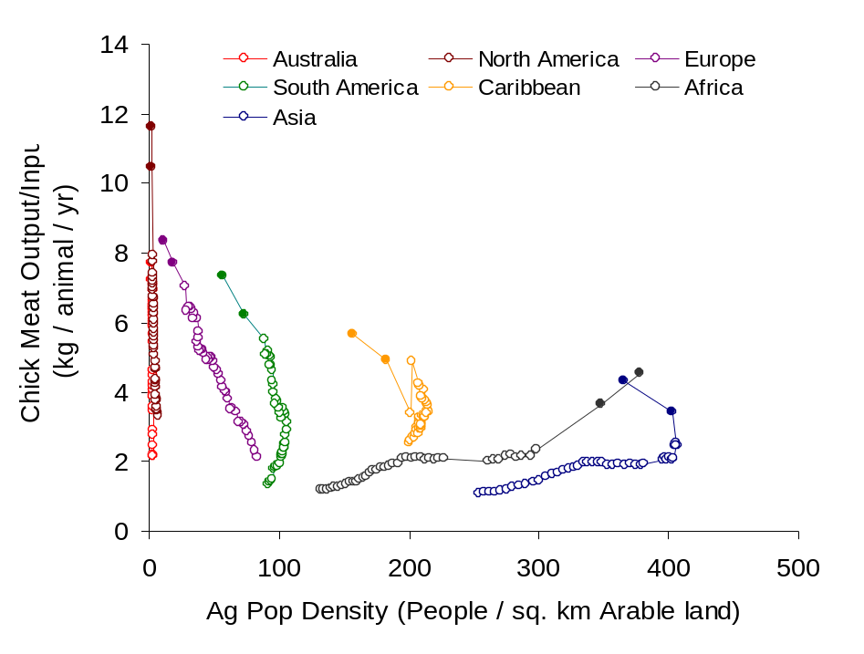
Fig. 1.3 Change in chicken meat output/input and agricultural population density grouped by continent between 1961 and 2001 (empty circles) and predicted for 2015 and 2030 (full circles).

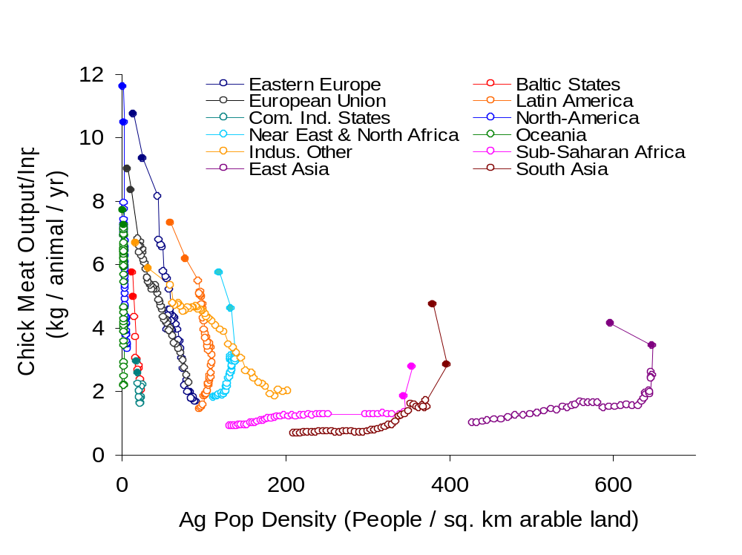
Fig. 1.4 Change in chicken meat output/input and agricultural population density grouped by FAO region between 1961 and 2001 (empty circles) and predicted for 2015 and 2030 (full circles).

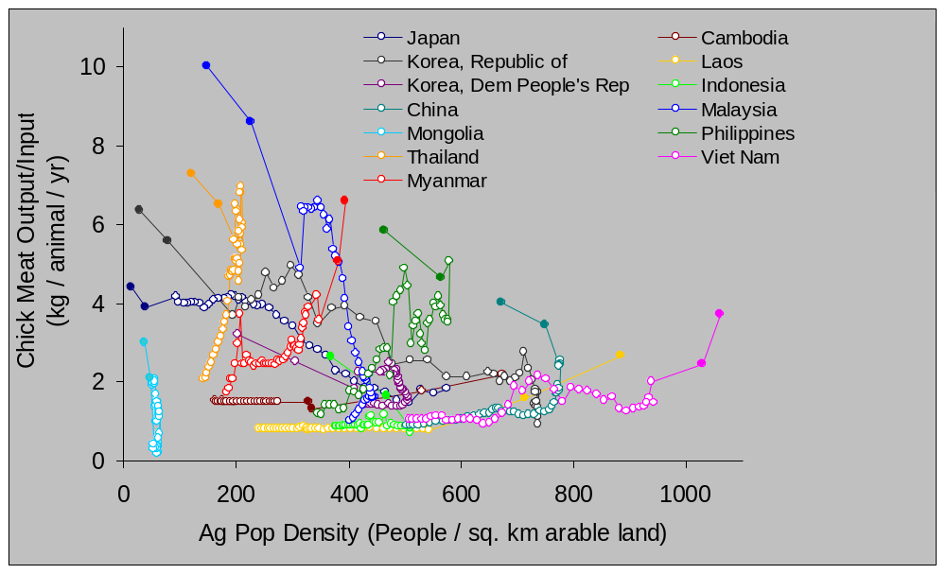

Fig. 1.5 Change in chicken meat output/input and agricultural population density for East-Asia countries between 1961 and 2001 (empty circles) and predicted for 2015 and 2030 (full circles). This plot is presented in two parts in Appendix III.
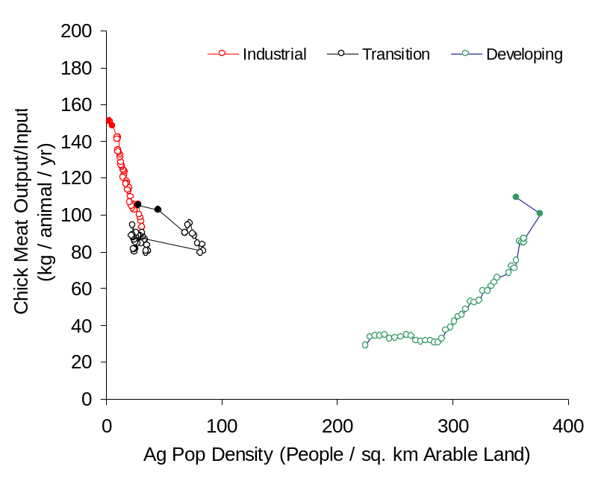
Fig. 1.6 Change in pig meat output/input and agricultural population density grouped by industrialization level between 1961 and 2001 (empty circles) and predicted for 2015 and 2030 (full circles).
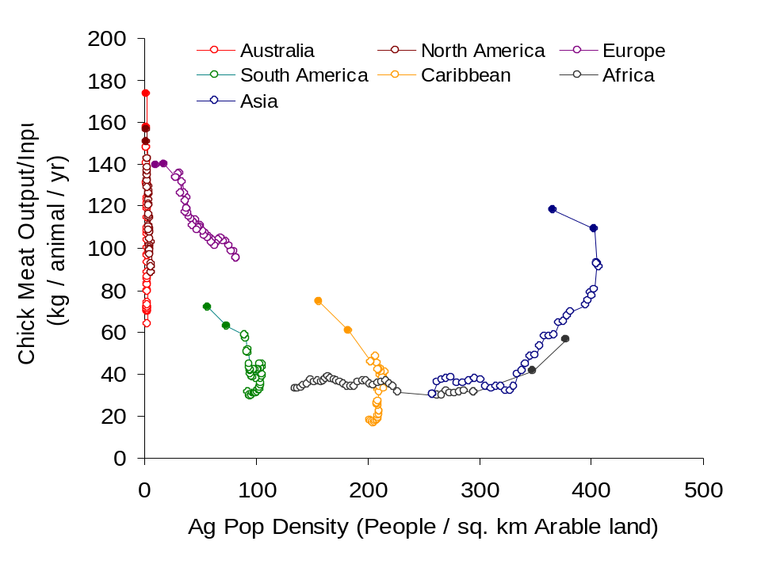
Fig. 1.7 Change in pig meat output/input and agricultural population density grouped by continent between 1961 and 2001 (empty circles) and predicted for 2015 and 2030 (full circles).

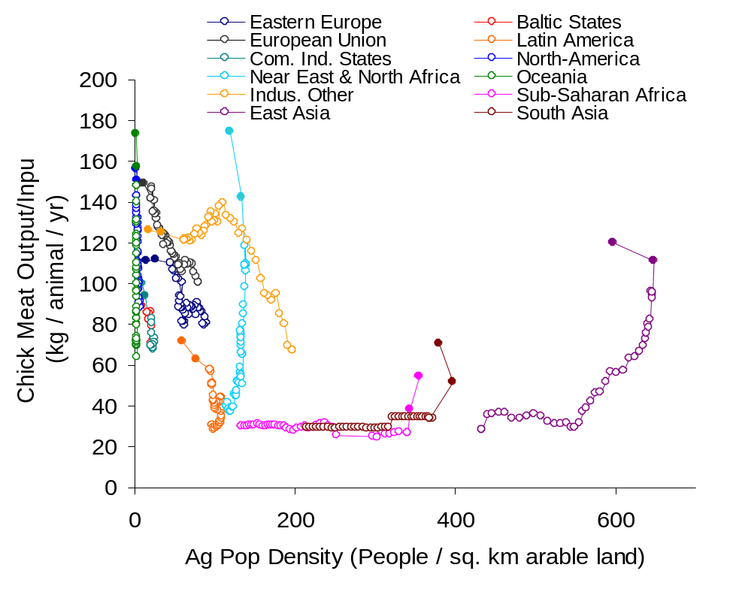
Fig. 1.8 Change in pig meat output/input and agricultural population density grouped by FAO region between 1961 and 2001 (empty circles) and predicted for 2015 and 2030 (full circles).
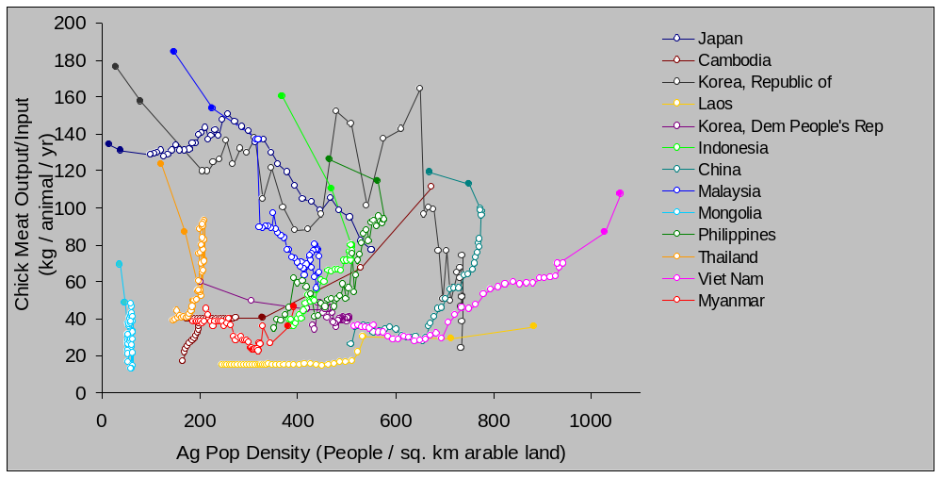

Fig. 1.9 Change in pig meat output/input and agricultural population density for East-Asia countries between 1961 and 2001 (empty circles) and predicted for 2015 and 2030 (full circles). This plot is presented in two parts in Appendix III.

The consistent patterns evident from the regional scale analyses are not found at the country level which show very diverse trajectories (Figs. 1.5 & 1.9). An expected pattern would be that any increase in the productivity should translate in a reduced number of agricultural people because less producers are required to meet the demand. For chickens (Fig. 1.5), this expected pattern appears to be rather exceptional and is observed only for Japan, South Korea and to some extent Mongolia. AgPop density increased in all other countries (except Mongolia that remained approximately static), together with marked productivity increases (Thailand, Myanmar, Philippines, or somewhat lesser productivity increases (Cambodia, Viet Nam, North Korea, China). A rather similar picture is observed in pig production, except that bigger increases are noted in pig productivity, along with a higher variability.

These results support three main observations. Firstly, Asia, and East Asia in particular, are distinct from other regions in the world, and are characterised by a low increases in productivity alongside a very significant rise in the agricultural population density. This indicates that this area can not be compared to other regions in the world in relation to epidemic risk. Secondly, the fact that intensification does not translate into a reduction of Agpop density suggests that intensification is changing more slowly than the overall human population levels, i.e. the fall in the number of agricultural people due to production intensification is overtaken by the increase in agricultural people as a whole. Thirdly, given that epidemic risk is highest where production is in transition between extensive and industrial and there is a high density of smallholders, the fact that intensification is accompanied by a rise in the density of smallholders in several countries implies they are high risk areas. Finally, it also suggests that intensification may in some countries actually lead to a dichotomy in production systems, with a consistently increasing number of smallholders and some very intensive production units concentrated around consumption areas, translating in an overall output/input increase. This can only be evaluated by similar studies carried out at sub-national levels to identify such areas.

Theoretical trajectories under an assumption of self-sufficiency

The trajectories observed in East-Asia suggest that under certain circumstances, gains in productivity may not translate into a reduction of the agricultural population. In order to understand this better, we looked at the intrinsic relationships between productivity and agricultural population changes by modelling changes in agricultural population in response to i) increases in productivity, and ii) increases of the overall human population, under the assumption of self-sufficiency (no import, no export, the production always meets the demand).

The first step was to relate gains in productivity to decreases in proportion of farmers. If the productivity (Pry) is expressed as production per farmer (e.g. kg meat per farmer), and that the demand per capita is constant in time, the two variables are simply inversely related:

Say that:

P = Total production Pop = total human population
Nf = Number of farmers Dem = demand per capita
Pry = Productivity per farmer Pf = Proportion on farmers
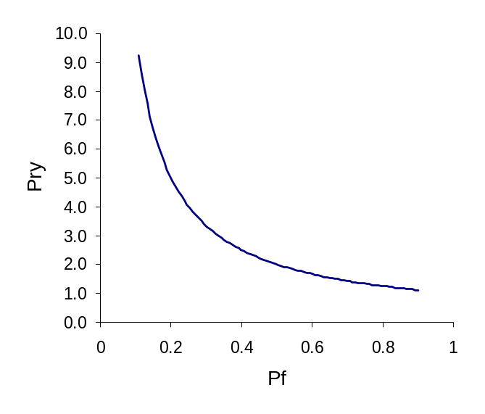
We have

P = Nf . Pry (1)

from which

Pry = P / Nf (2)

We also have

P = Dem . Pop (3)

From (2) & (3)

Pry = Dem . Pop / Nf

Since Pf = Nf / Pop, we have that

Pry = Dem / Pf (When Dem = 1, we have the plot as above)

Thus in essence, Pry and Pf are related, and fixing one variable fixes the other. It is important also to see that they are independent on the total population. The shape of the population increase has thus no influence on this relationship.

Looking at the change in these relationships over time, with 100 time steps, and assuming that Dem = 1, if the proportion of farmers decreases linearly with time as Pf = 0.9 – 0.008 t, then Pry increases as Pry = 1 / (0.9 – 0.008 t) giving the two plots below.

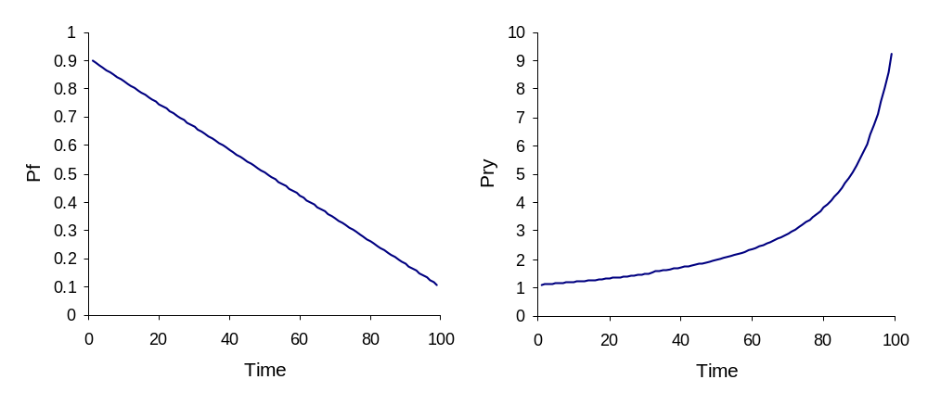
A
B

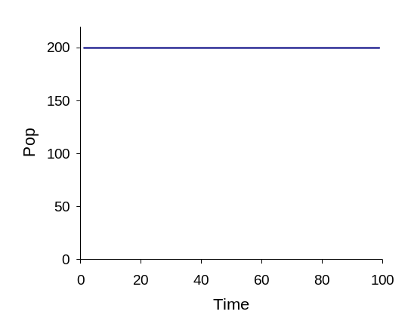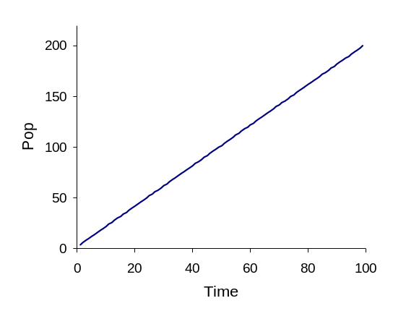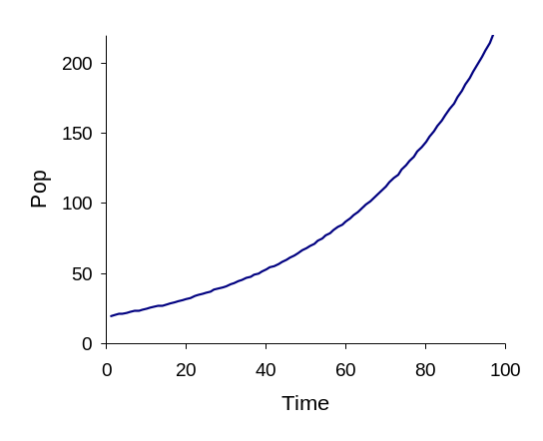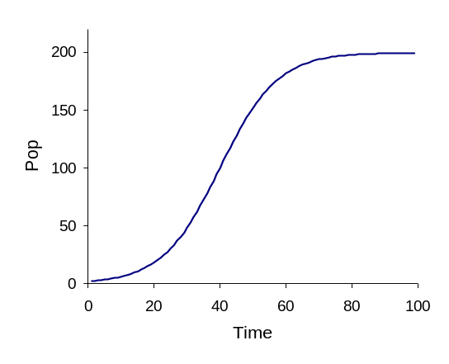
C
D
E
F
As a country has a fixed area, the absolute number of farmers Nf can be used instead of density, and Nf is simply equal to Pop.Pf. Thus the shape of Nf over time is entirely determined by Pf (plot A) and Pop change as a function of time. With three different Pop growth patterns: a constant (C), a linear growth (D), an exponential growth (E), and a logistic growth (F) the change in the number of farmers translates to the curves shown below
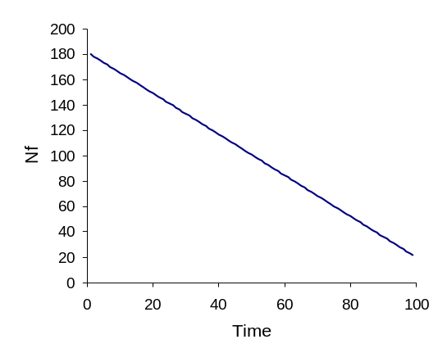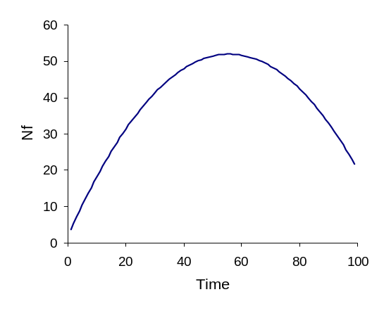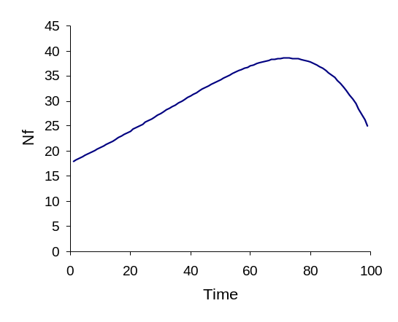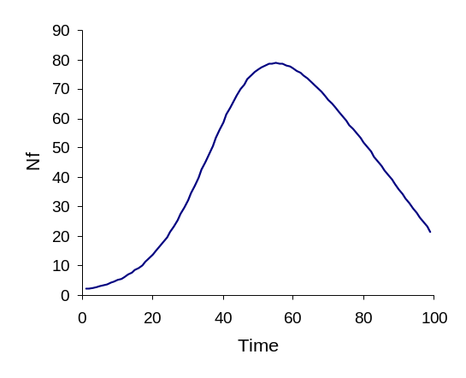

If the Pry is then plotted as a function of Nf (representing Productivity vs. AgPop), the patterns are as shown below .

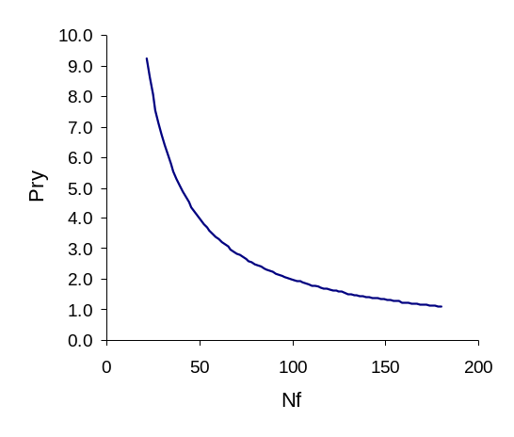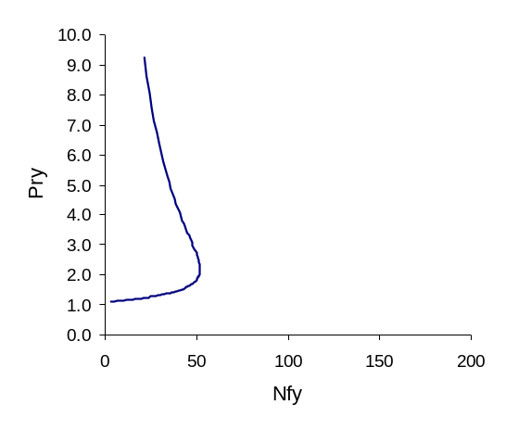
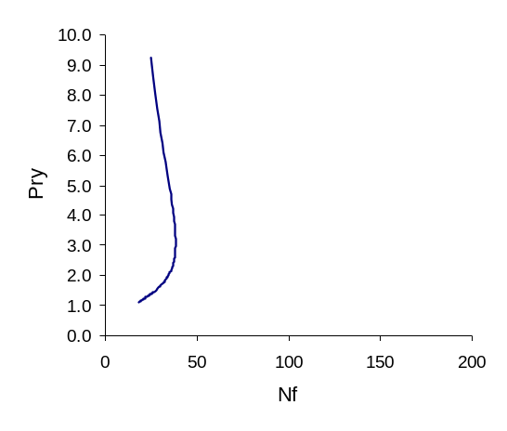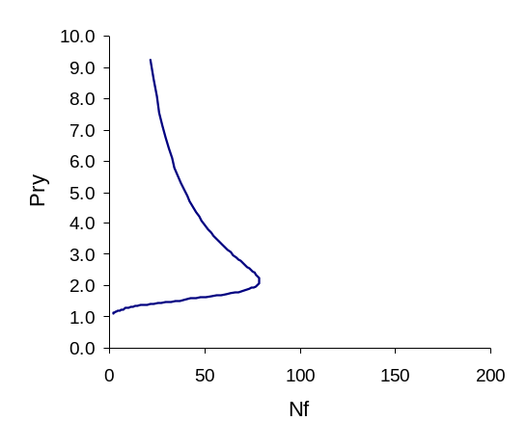
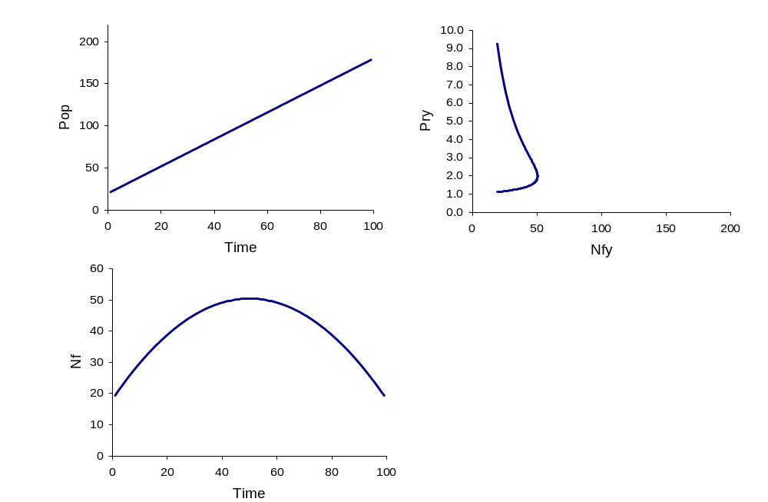
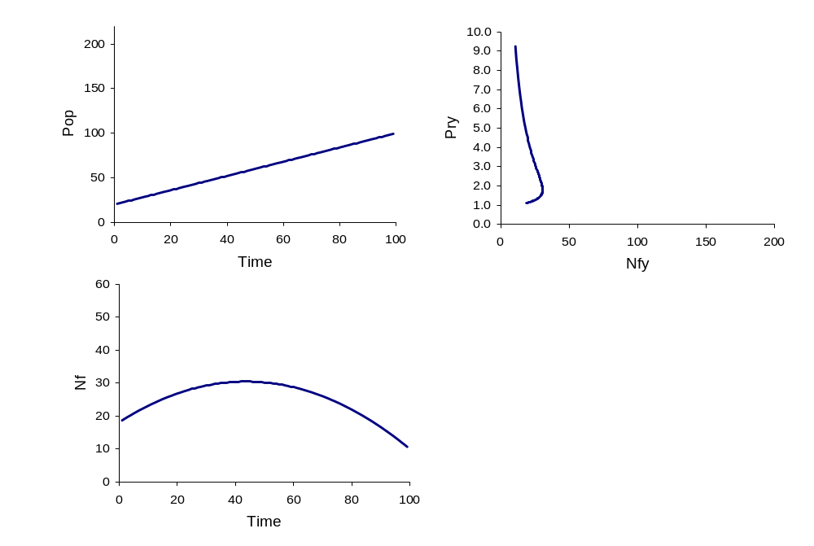
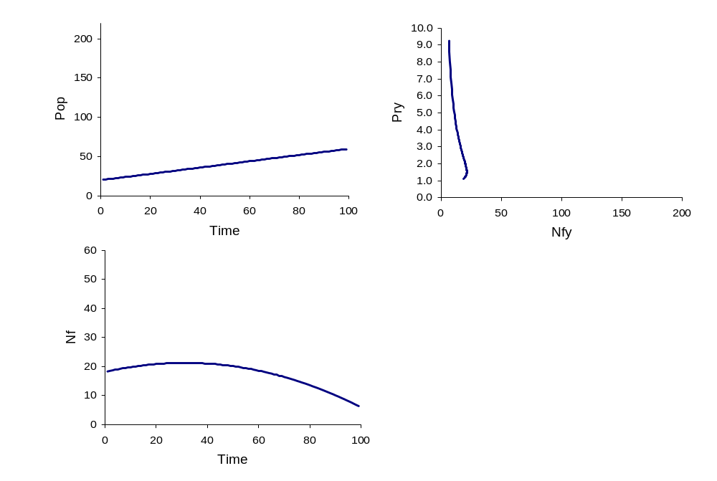
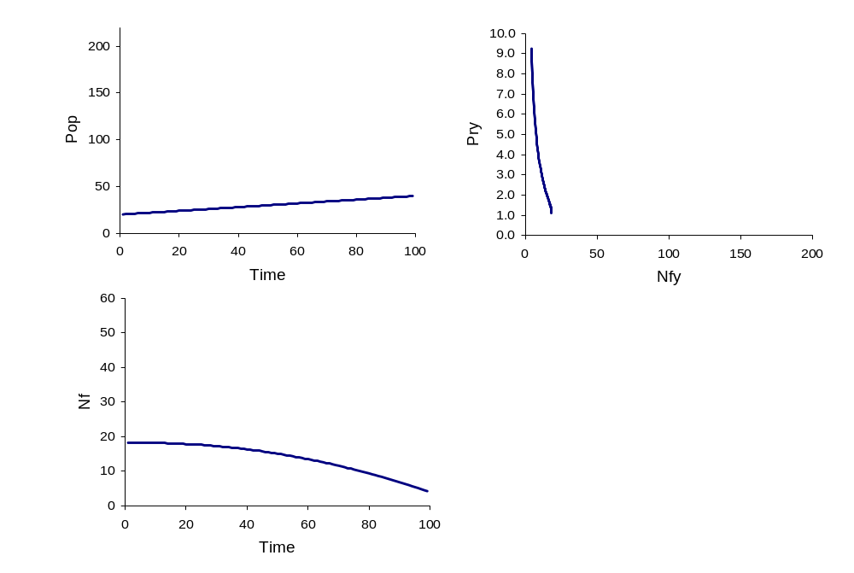
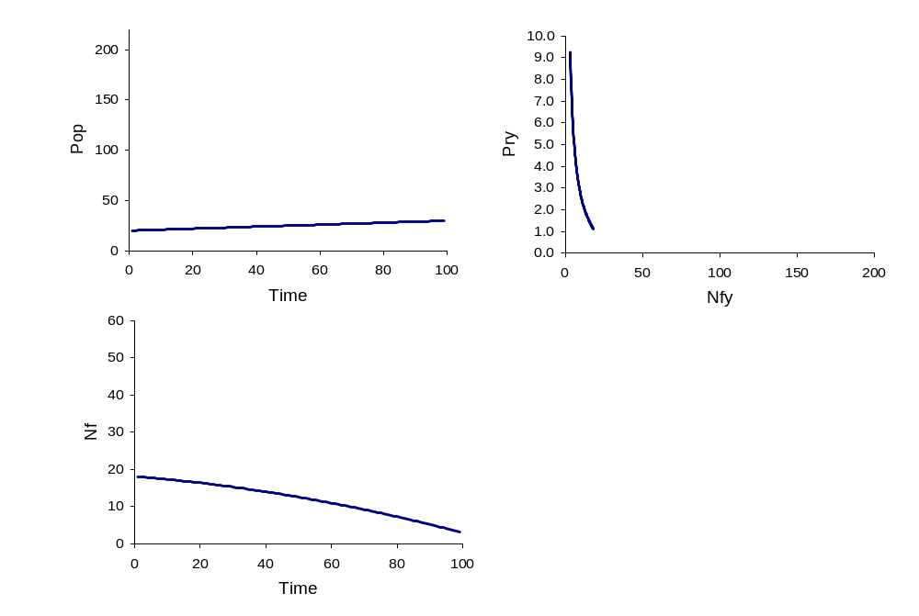
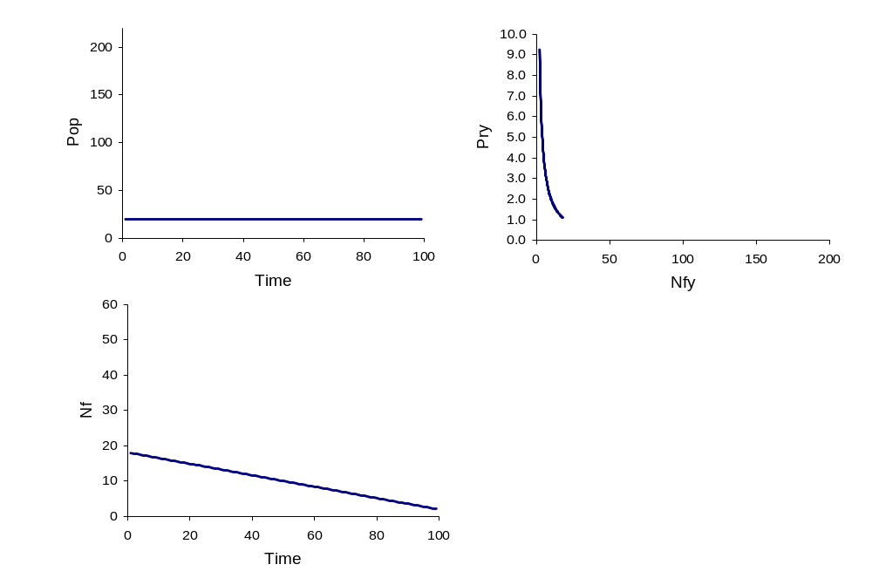
So, from the 8 plots above, in all cases where Nf goes from nearly 10 to 200, there is a maximum in the Nf at some point which corresponds to the little bump in the Pry vs. Nf plots which does not depend greatly on the pattern the human population growth. This being so, it is justifiable to base further models on the simplest assumptions by using a linear model of population increase, and changing the rate of increase (R):
R = 0
R = 0.1
R = 0.2
R = 0.4
R = 0.8
R = 1.6
So, these trajectories and their shape depend mostly on the interaction between changes in proportion of farmers (or changes in productivity), and changes in total population. If Pf decreases slowly, a minor increase in Pop will create a maximum in Nf. If Pf decreases sharply, then a higher rate of increase in Pop is necessary to observe such maximum.

This can be derived mathematically: with Nf = Pf.Pop, and Pf and Pop being both linear function of time (Pf = a – bt; Pop = c + dt), Nf has a maximum when the derivative of (a-bt).(c+dt) equals zero.

Nf = (a-bt).(c+dt)

Nf = ac + adt –bct –bdt²

Nf = ac + (ad – bc).t –bdt²

We take the derivative of the above function

dNf / dt = ad – bc –2bdt

we set it to zero

0 = ad – bc –2bdt

2bdt = ad – bc

and we have

t = (ad – bc)/2bd

Since t cannot be negative, and b and d are strictly positive, a maximum can be observed if ad > bc. This can be verified with the example illustrated above, with a = 0.9; b = 0.008; c = 20, thus a maximum is present if 0.9d > 0.16, then if d > 0.177 One can see in the plots above that R = 0.177 is the limit above which Nf as a function of time starts showing a maximum.

To calculate Pry as a function of Nf (the productivity vs. farmer density trajectories considered in the last section), both variables must be expressed as a function of time, and then Pry as a function of Nf, giving:

Nf = ac + (ad – bc).t –bdt² (4)

Pry = Dem / Pf
Pry = Dem / (a-bt)

thus t = (a/b) – (Dem/bPry) (5)

then replacing t by (5) in (4) which simplifies as:

Nf = (ad/b + c).Dem/Py – d.Dem²/Py²

Then by expressing Py as a function of Nf, the conditions for the trajectory to go to the right (slope > 0, thus first derivative positive), or to the left (negative slope, thus first derivative is negative) can be identified. This analysis could be replicated by considering that Pop = f(t), or Pf = f(t) functions are not linear, or that Dem is also a function of time, but this would go beyond the scope of the present study.
The main outcome of the model approach developed above is that it demonstrates that trajectories such as those observed in East-Asia may be generated by the simple combination of two processes: demographic growth and production intensification. It also highlights the critical role of the rate of increase in human population in increasing the number of farmers in higher epidemiological risk areas, and this despite significant changes in the production intensity.

Output / input and agricultural population as predictors for annual status in poultry OIE list A diseases.

A further step in testing the role of OI/AgPop in determining ecological risk is to test these two variables against available disease data, here represented by the annual disease status as recorded by the OIE for List A diseases of poultry: Newcastle disease (ND) and highly pathogenic avian influenza (HPAI). It was shown in the previous section that Asia is distinct in terms of OI/AgPop trajectories. It was thus decided to concentrate this analysis on South and East Asian countries, namely: Bangladesh, Cambodia, China, India, Indonesia, Japan, North Korea, South Korea, Laos, Malaysia, Mongolia, Myanmar, Pakistan, Philippines, Sri Lanka, Thailand and Vietnam. The disease status expressed as presence/absence of ND and HPAI was extracted from OIE Handistatus II for the period 1996-2002, and recorded from OIE/FAO yearbooks for the years 1975, 1980, 1985, 1990-1995. Data from all years and countries were pooled and the presence/absence was tested against OI, AgPop, OI², AgPop² and Chickens stock (CS) (animals / sq. km) using a statistical logistic regression model.

Newcastle disease

Classification Table(a)

 | Observed |  | Predicted
 |  |  | ND Status |  |  | Percentage Correct
 |  |  | .00 | 1.00
Step 1 | ND Status | .00 | 7 | 17 |  | 29.2
Step 1 |  |  | 1.00 |  | 3 |  | 210 |  | 98.6
Step 1 | Overall Percentage |  |  |  |  | 91.6

 |  | B | S.E. | Wald | df | Sig. | Exp(B)
Step 1(a) | AgPop | .0135 | .00447 | 9.162 | 1 | .002 | 1.014
Step 1(a) | AgPop² | -7.34 10⁻⁶ | 5.34 10⁻⁶ | 1.920 | 1 | .166 | 1.000
Step 1(a) | OI | .541 | .512 | 1.115 | 1 | .291 | 1.718
Step 1(a) | OI² | -.100 | .071 | 2.029 | 1 | .154 | .904
Step 1(a) | CS | 1.212 10⁻¹⁰ | 9.88 10⁻¹⁰ | .015 | 1 | .902 | 1.000
Step 1(a) | Constant | -1.174 | .756 | 2.411 | 1 | .121 | .309

A backward removal procedure to remove variables with a significance. > 0.10, obtained the following model:

 |  | B | S.E. | Wald | df | Sig. | Exp(B)
Step 1(a) | AgPop | .015 | .004 | 13.382 | 1 | .000 | 1.015
Step 1(a) | AgPop² | -9.24 10⁻⁶ | 4.84 10⁻⁶ | 3.645 | 1 | .056 | 1.000
Step 1(a) | OI² | -.028 | .017 | 2.892 | 1 | .089 | .972
Step 1(a) | Constant | -.773 | .644 | 1.441 | 1 | .230 | .462

Which can be displayed in the OI/AgPop space as:
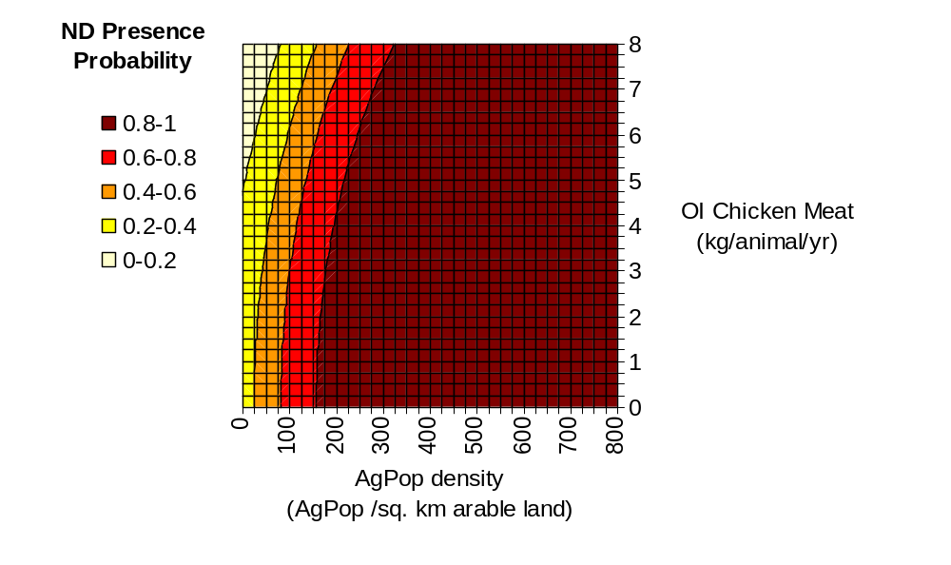

Highly pathogenic avian influenza

Because there was a low observed proportion of positives, the classification threshold had to be adjusted to 0.35.

 | Observed |  | Predicted
 |  |  | AI status |  |  | Percentage Correct
 |  |  | .00 | 1.00
Step 1 | AI Status | .00 | 139 | 30 |  | 82.2
Step 1 |  |  | 1.00 |  | 18 |  | 29 |  | 61.7
Step 1 | Overall Percentage |  |  |  |  | 77.8
a The cut value is .350

 |  | B | S.E. | Wald | df | Sig. | Exp(B)
Step 1(a) | AgPop | .00233 | .00293 | .632 | 1 | .427 | 1.002
Step 1(a) | AgPop2 | -4.10 10⁻⁶ | 2.86 10⁻⁶ | 2.057 | 1 | .152 | 1.000
Step 1(a) | OI2 | -.326 | .136 | 5.767 | 1 | .016 | .722
Step 1(a) | OI | 1.255 | .668 | 3.526 | 1 | .060 | 3.506
Step 1(a) | CS | -4.32 10⁻¹⁰ | 3.80 10⁻¹⁰ | 1.293 | 1 | .256 | 1.000
Step 1(a) | Constant | -1.699 | .734 | 5.360 | 1 | .021 | .183

A backward removal procedure to remove variables with a significance. > 0.10, obtained the following model:

 |  | B | S.E. | Wald | df | Sig. | Exp(B)
Step 1(a) | AgPop2 | -2.221 10⁻⁶ | 8.798 10⁻⁷ | 6.373 | 1 | .012 | 1.000
Step 1(a) | OI2 | -.358 | .130 | 7.580 | 1 | .006 | .699
Step 1(a) | OI | 1.427 | .631 | 5.114 | 1 | .024 | 4.166
Step 1(a) | Constant | -1.450 | .623 | 5.421 | 1 | .020 | .235

Which can be illustrated as:
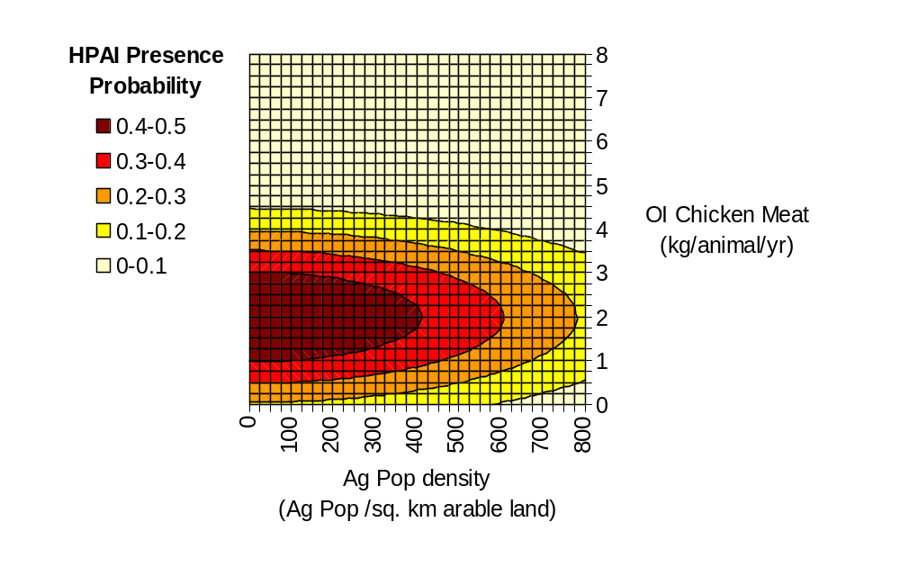
This analysis suggests i) that OI and AgPop are generally better predictors than the absolute number of exposed animals which is classically related to disease persistence, ii) that the probability of ND and HPAI presence generally decreases as a function of OI, and iii) the relationship between disease presence and AgPop density is positive in ND and negative in HPAI.
ND and HPAI have very different distribution patterns. ND is generally widespread in South and East Asia, and was absent only in 24/237 countries.years. The relationship with the predictors thus mainly shows countries where it was absent for more than one consecutive year: Japan, Mongolia and Thailand. As all countries except Thailand with AgPop density > 150 had reported ND as present is it not possible to quantify the risk in them.
An opposite pattern was observed for HPAI which was mainly absent, and only present in 37/206 countries.years. Several countries reported HPAI for more than one year: Cambodia, China, North Korea, Laos, Mongolia, Myanmar, Pakistan & Viet Nam, which were mostly concentrated in the lower left part of the plot (low OI, and low AgPop) when the HPAI status was positive (e.g. China, North Korea: 1975-1990).

This analysis has several limitations. Firstly, we have seen that many countries have very different trajectories in the OI/AgPop space. This means that the analysis has to be focused within regions having similar patterns, and given the dichotomy between Asia and other continents (Fig. 1.4), a single analysis with European and Asian countries pooled together cannot be undertaken . This reduces in the number of countries considered, and accordingly the statistical results are not very stable as they depend heavily on a small number of individual countries.
Secondly, the annual records are not truly independent observations as these data are time-series of disease status, and the status in any given year may well be closely correlated to that in the previous year. Although an autoregressive model might account for this, it would reduce the significance level of predictors to a point where no explanatory variable is significant because of few truly independent observations.
Thirdly, each country figure filters out sub-national variability, and a country may have several high risk small areas at the sub-national level that would not appear in the national averaged numbers.
Therefore, the results presented in this section should be interpreted cautiously, and indicate main trends that would need to be confirmed by refined analyses carried out at the sub-national levels.

The 2004 HPAI outbreaks as study case to explore the association between poultry disease risk and output/input and agricultural population density.

Moving to a sub-national analysis was particularly appealing given the large number of geo-referenced records on individual HPAI outbreaks recorded in East Asia in early 2004. However very little information on production structure, production volumes or agricultural population was available at the sub-national level, and certainly not at the pixel resolution needed to identify concentrations of people and animals around cities. It was thus necessary to identify surrogate variables for productivity and to model the national production and AgPop figures using data for which comparatively high resolution distributions are available.

AgPop distribution

The distribution of human population is available at a resolution of 0.00833 decimal degrees (approx 1kilometre) in the Landscan database (Budhendra et al. 2002). This data layer was used by FAO (LEAD) to derive the distribution of rural human populations in east Asia by removing the pixels classified as cities or suburbs in the Landscan 1998 landcover database, and by multiplying the remaining values by correction factors to match national figures recorded in FAOSTAT. These data were available from FAO GeoNetwork Portal (http://www.fao.org/geonetwork/srv/en/main.search), but did not include Japan. A similar analysis as described for the FAO LEAD data was thus repeated starting from the updated Landscan 2002 database, and by using the FAOSTAT 2002 population national figures to re-scale rural population totals.

A tight relationship between the calculated rural population and FAOSTAT agricultural population is observed at the national scale (Fig. 4.1), and it was therefore assumed that the same relationship could be applied at sub-national level to generate the pixel resolution distribution of AgPop in 2002. Therefore, the model was applied to the rural population density distribution layer to obtain a AgPop density distribution layer. This layer was re-scaled by country multipliers to match FAOSTAT AgPop country totals (Fig. 4.2.)

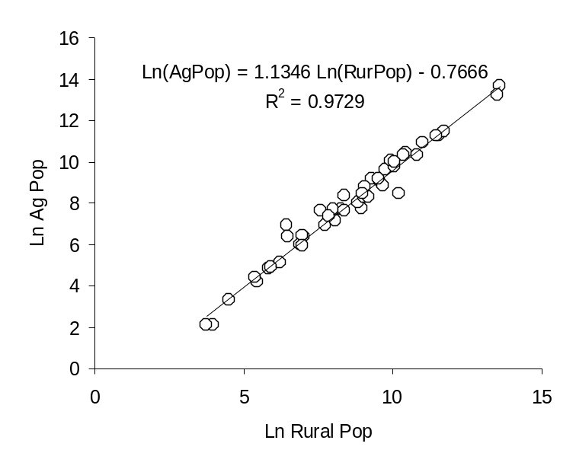
Fig. 4.1 Relationship between ln(Agricultural population) and ln(Rural population) national totals extracted from FAOSTAT for 2002.

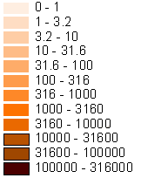
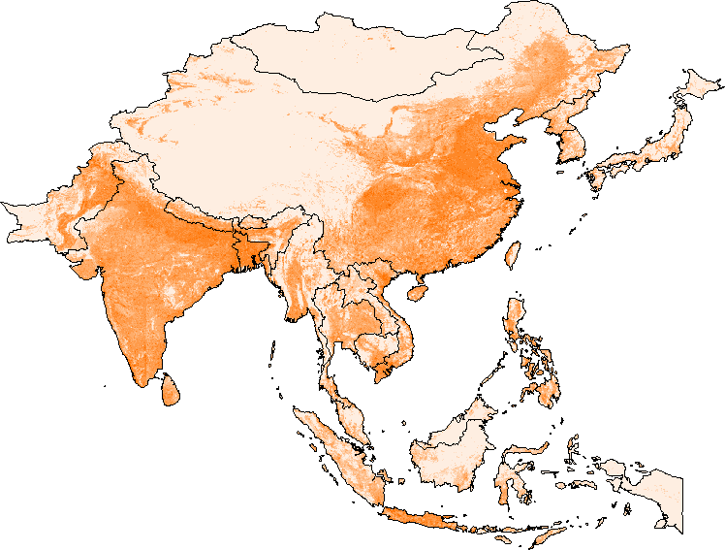

Fig. 4.2 Distribution of Agricultural population density in South and East Asia in 2002

Livestock distribution and productivity

The only data available on poultry distributions were a raster layer of poultry livestock density and national figures on production from FAOSTAT. The main assumption used to generate layers of productivity was that the production in any given area is the result of two production types: backyard smallholder production, and intensive/industrial production. The first step was thus to build raster GIS layers of poultry livestock being held in extensive (Le) and intensive (Li) production systems.

Little quantitative information is actually available on country-level production structure. However, by collating data from different sources (Agricultural Census of China 1997, Glipha 2004, FAO 2003), it was possible to estimate the proportion of livestock produced by smallholders in Cambodia, China, Indonesia, Laos, Thailand and Vietnam, which is closely related to the production output/input ratios as shown in Fig. 4.3
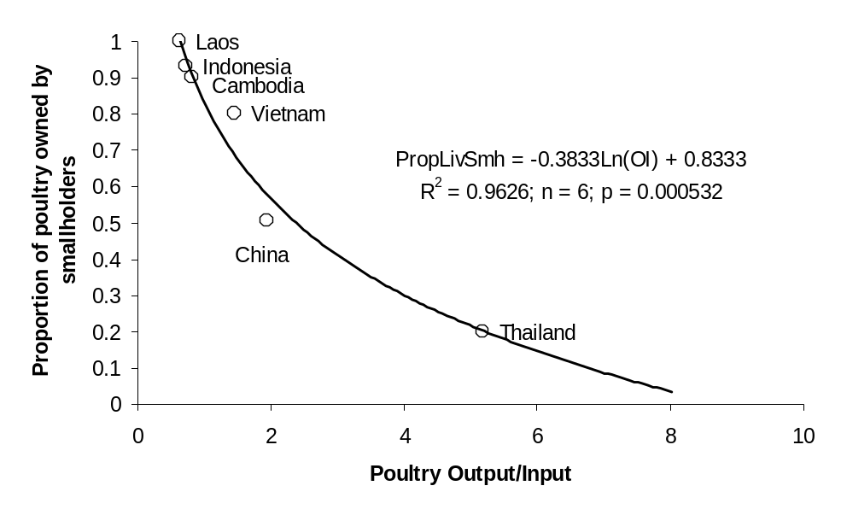
Fig. 4.3 Relationship between the proportion of livestock held by smallholders and ln(poultry production output/input) derived from FAOSTAT for 2002.

This relationship was used to estimate the proportion of livestock held by smallholders in all other countries as a function of the observed output/input, from which value the total poultry livestock held by smallholders in each country was obtained. When divided by the agricultural population number from FAOSTAT the smallholder livestock estimate provided the average number of poultry held per agricultural perrson in each country. These national figures were then multiplied by the raster layer of Agpop (Fig. 4.2) to obtain a raster layer of the distribution of poultry livestock held in extensive systems (Le). The distribution of livestock held in intensive/industrial systems (Li) was thus simply obtained as L – Le, where L is the raster layer of total poultry livestock distribution. The distribution of Le and Li are presented in figures 4.4.

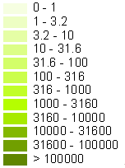
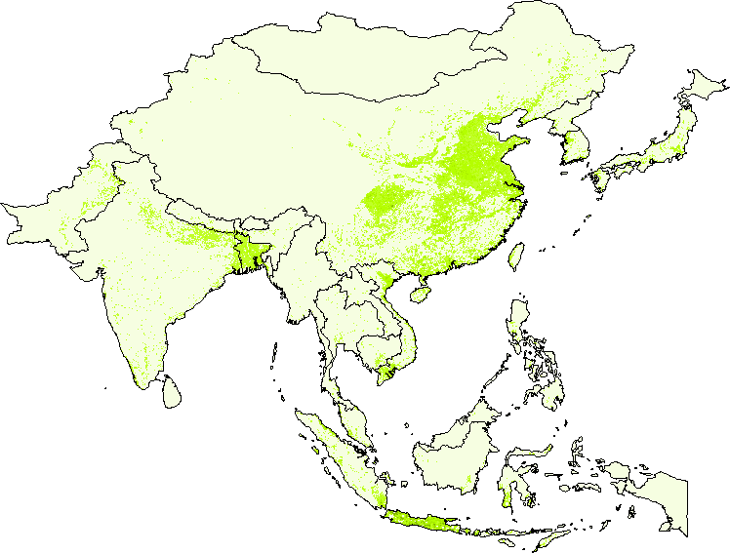
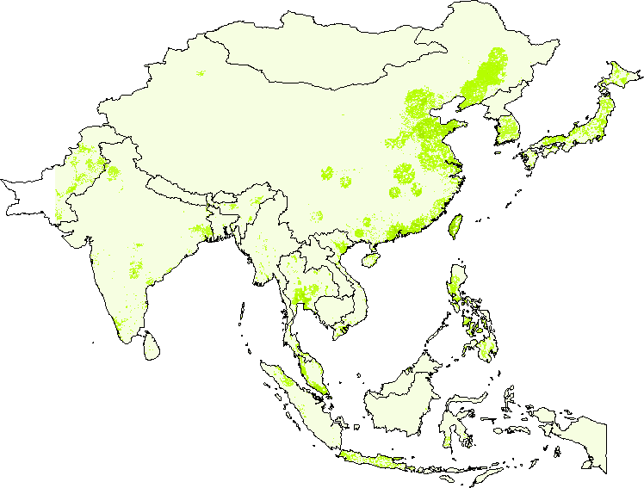

Fig. 4.4 Distribution of poultry livestock density (animals / sq. km) held in extensive (above) and intensive/industrial (below) production systems.

The second step was to derive production layers (meat kg per year) associated with extensive systems (Pe) and intensive/industrial production systems (Pi). The intensive/industrial system is quite variable from one country to another and depends on how far a country has progressed along the production intensification process. However, the productivity of extensive systems is much less variable and was estimated as the average OI of countries were the proportion of poultry held by smallholders was > 90%. Thus the productivity of 0.839 kg / head / year was applied to Le to derive Pe, the distribution of production by extensive production systems.

Country-level figures of total production in extensive systems (Tpe) was estimated from the distribution of Pe. The total production in intensive systems was then estimated as Tpi = Tp – Tpe, where Tp is the total country production from FAOSTAT. National-level productivity figures for intensive/industrial production was thus estimated as Tpi/Tli, where Tpi was estimated as described above, and Tli is the country-level total poultry livestock in intensive/industrial production systems. Li was then multiplied by these country-level productivity multiplers to obtain the distribution of the production by intensive/industrial systems (Pi).

Finally, the Output/Input distribution layer was thus simply obtained as (Pe + Pi) / (Le + Li). The distribution of Output/Input is presented in Fig. 4.5 and Table 4.1 summarises some key variables used in this procedure.

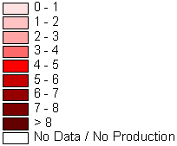
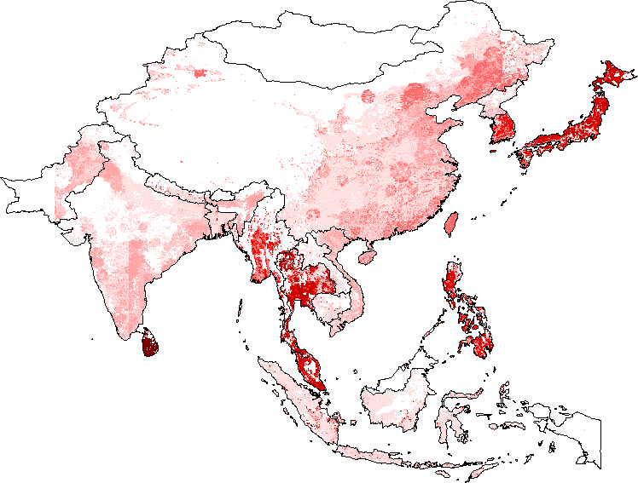

Fig. 4.5 Distribution of poultry production output/input expressed in kg / year / head in South and East Asia.

Table 4.1 Variables used to derive sub-national distributions of poultry livestock and production.

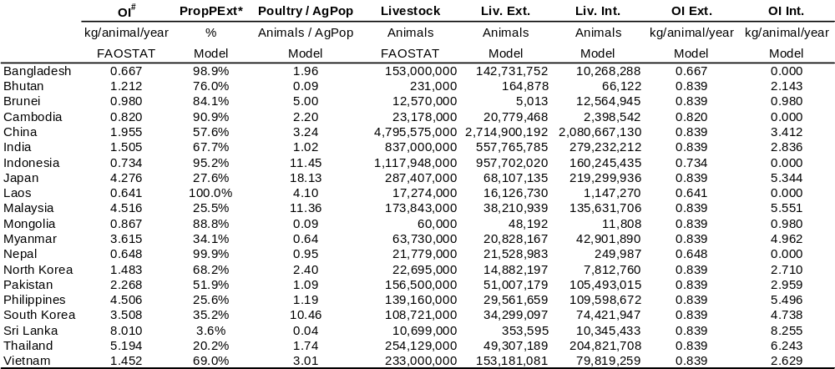
# Output/input; * Proportion of livestock held by smallholders; Liv. Ext. is the livestock held in extensive production units, Liv. Int is the livestock held in intensive/industrial production units.

HPAI outbreaks as a function of agricultural population and output/input

The aim of this analysis was to test the spatial distribution of observed HPAI outbreaks in the recent 2004 epidemic against the productivity and agricultural population density variables, in addition to a series of classical predictors of disease occurrence such as host animal density or human population density.

The first step consisted of establishing the locations of recorded HPAI outbreaks. The locations of outbreaks observed in Cambodia, China, Japan, Taiwan, South Korea, Thailand and Vietnam had already been identified in the EMPRES-I database at the time of the present study. The outbreaks in Laos were also obtained from EMPRES-I, and their location was found using the NIMA GeoNet Name Server. Some outbreak locations could not be found in the database, in which case they were assigned to the centroid of the administrative level 2 polygon to which they belonged.

Finding the association between outbreak locations and a series of variables requires the characterisation of the variables under study in areas where the disease was not reported (absent cases). A layer of disease-absence locations was generated were chosen at random within the countries where HPAI was reported, with 4 times more points than the reported number of outbreaks (e.g. 8 outbreaks were recorded in the database for Japan, hence 32 absence points were distributed randomly in Japan). This layer was then corrected so that disease-absence points could not fall within the same 0.083 degree (approx 10km) pixel as observed positives.

This process produced a database of1215 locations with 243 records of HPAI outbreaks, and 972 locations randomly distributed within affected countries at a distance > 0.083 decimal degrees from any recorded positive (Fig. 4.6). Values for the following predictor variables were extracted from the GIS data layers for each point location: Poultry livestock density (L), Poultry livestock density in extensive systems (Le), Poultry livestock density in intensive/industrial systems (Li), Agricultural population density (AGP), the Poultry production output/input (OI), the human population density (HP), the distance to the nearest city (DIST), the inverse distance to the nearest city (IDIST). These predictors were tested against the HPAI presence/absence using a statistical multiple logistic regression model.

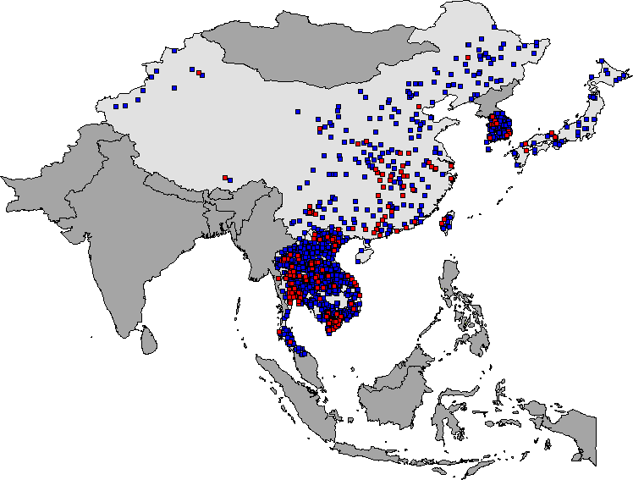
Fig. 4.6 Distribution of HPAI observed outbreaks (red dots) and randomly distributed negatives (blue dots) in HPAI presence countries (light grey).

The model was built using a supervised forward entry procedure to build the logistic model, which is detailed below. First, all variables quantifying livestock numbers (L, Le and Li) were tested as predictors of the dependent variable:

 |  |  | Score | df | Sig.
Step 0 | Variables | L | 100.584 | 1 | 1.14 10-²³
Step 0 | Variables | Lex | 199.637 | 1 | 2.514 10-⁴⁵
Step 0 | Variables | Lin | 16.648 | 1 | 4.5 10-⁵
Step 0 | Overall Statistics |  | 216.040 | 3 | .000

Le clearly ranked first (by far the highest score = 199), and was thus entered in the model. Variables describing the production structure were entered at a second stage: OI, DIST, TDIST.

 |  |  | Score | df | Sig.
Step 1 | Variables | OI | 4.192 | 1 | .041
Step 1 | Variables | DIST | 71.156 | 1 | 3.30 10-¹⁷
Step 1 | Variables | IDIST | 38.066 | 1 | 6.84 10-¹⁰
Step 1 | Overall Statistics |  | 80.953 | 3 | .000

Here DIST ranked first among these three variables. Finally, variables describing the human population (HP) and agricultural population (AGP) where tested after Le and DIST.

 |  |  | Score | df | Sig.
Step 2 | Variables | AGP | 1.295 | 1 | .255
Step 2 | Variables | HP | 5.601 | 1 | .018
Step 2 | Overall Statistics |  | 6.929 | 2 | .031

Here human population ranked first. Thus the final model includes the poultry livestock density held in extensive production systems (Le), the distance to the nearest city (DIST) and the human population density (HP). Finally, countries was entered as a categorical variable, and the details of the model are presented below:

 | Observed |  | Predicted
 |  |  | HPAI |  |  | Percentage Correct
 |  |  | .00 | 1.00
Step 1 | HPAI | .00 | 943 | 29 |  | 97.0
Step 1 |  |  | 1.00 |  | 139 |  | 103 |  | 42.6
Step 1 | Overall Percentage |  |  |  |  | 86.2
a The cut value is .500

 |  | B | S.E. | Wald | df | Sig. | Exp(B)
Step 1(a) | Lex | .001 | .000 | 44.002 | 1 | .000 | 1.001
Step 1(a) | DIST | -5.971 | .690 | 74.968 | 1 | .000 | .003
Step 1(a) | HP | .0000789 | .0.000032 | 6.435 | 1 | .011 | 1.000
Step 1(a) | ccode |  |  | 49.138 | 8 | .000
Step 1(a) | ccode(1) | 1.263 | .509 | 6.151 | 1 | .013 | 3.538
Step 1(a) | ccode(2) | .345 | .315 | 1.198 | 1 | .274 | 1.412
Step 1(a) | ccode(3) | .440 | .517 | .724 | 1 | .395 | 1.552
Step 1(a) | ccode(4) | 2.143 | .377 | 32.323 | 1 | .000 | 8.528
Step 1(a) | ccode(5) | -1.026 | 1.666 | .379 | 1 | .538 | .359
Step 1(a) | ccode(6) | .259 | .393 | .433 | 1 | .510 | 1.296
Step 1(a) | ccode(7) | .258 | .925 | .077 | 1 | .781 | 1.294
Step 1(a) | ccode(8) | 1.267 | .324 | 15.254 | 1 | .000 | 3.549
Step 1(a) | Constant | -1.683 | .329 | 26.105 | 1 | .000 | .186
a Variable(s) entered on step 1: Lex, DIST, HP, ccode.

A risk index map was built on the basis of the above model and is presented in Fig. 4.7.

This analysis yields three important results. Firstly, it quantitatively demonstrates that the number of livestock held in extensive production units, i.e. in open contact with wildlife or other livestock sources of infection has more impact on disease risk than the absolute number of animals, which is a general prediction of epidemiological models. Moreover, the number of livestock held in intensive/industrial units showed the weakest association with HPAI outbreaks out of the three poultry livestock variables, suggesting that they have little impact on the epidemiological risk. This result highlights the role of agricultural population density as Le was simply estimated as the product of AgPop by national figures for the number of animals raised by agricultural people.

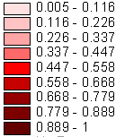
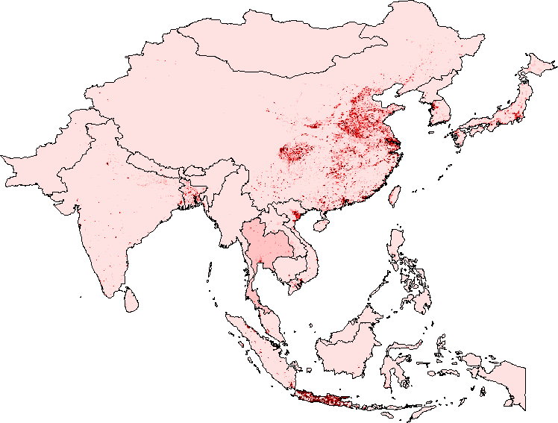
Fig. 4.7 Relative risk associated to HPAI outbreaks on the basis of observed associations between observed HPAI locations, poultry livestock density held in extensive production systems, distance to the nearest city, human population density and country.

Second, when quantifying the relationship between outbreak location and production structure, the distance to the nearest city a much better variable than output/input. This may relate to the fact that the output/input layer we have is a surrogate estimate generated on the basis of national figures of intensive/industrial productivity, whereas there might be some significant sub-national variations. Although this layer of OI was the best available in the absence of detailed sub-national data on production, it may not match the sub-national actual figures and explains why another surrogate estimate of production structure such as the distance to the nearest city provided much better result.
Finally, human population density also showed a significant association with HPAI outbreaks. This probably relates to infection pathways which are generally much more numerous in densely populated areas where there are higher flows of people and goods..

Conclusion

Through different quantitative and qualitative approaches, this work shows the critical importance of the production structure on epidemiological risk of monogastric livestock diseases. Contrary to expectation, increases in productivity do not always translate into a reduction of the number of smallholders, and thus in a general reduction of risk. East-Asia is one of the only areas in the world where the number of smallholders has increased alongside a progressive rise in agricultural productivity as a consequence of demographic growth. Quantitative analyses have shown that the density of agricultural people is an important predictor of epidemic risk, and that the worst cocktail of risk factors for the latest HPAI epidemic are areas close to cities, with a high human population density, and still a significant amount of extensive production units.
These results, and in particular the quantitative analysis of HPAI outbreak distribution could be further developed by i) stratifying the analysis to a lower level (the variables identified here may not act exactly in the same way in Thailand and in China), ii) use a similar approach to map the extensive production of pigs in Asia, iii) look at the pattern of risk in regions which are not yet in an areas of high risk such as South Asia, and Africa, iv) develop theoretical models of epidemics taking the production structure into account.

References

Antia, R., Regoes, R.R., Koella, J.C. & Bergstrom, C.T. (2003) The role of evolution in the emergence of infectious diseases. Nature 426:658-661.
Bruinsma, J.E. (2003) World agriculture: towards 2015/2030. An FAO perspective. Earthscan Publications ltd., London.
Budhendra,B., Bright,E., Coleman, P. & Dobson, J. (2002) LandScan: Locating People is What Matters. Geoinformatics 5(2): 34-37.
Centers for Disease Control and Prevention (2004) About the Emerging Infectious Diseases journal. http://www.cdc.gov/ncidod/eid/about/about.htm , Atlanta, USA.
Diamond, J. (2002) Evolution, consequences and future of plant and animal domestication. Nature 418:700-707
Dobson, A. & Foufopoulos, J. (2001) Emerging infectious pathogens of wildlife. Phil. Trans. R. Soc. Lond. B 356:1001-1012.
Keeling, M.J. (1999) The effects of local spatial structure on epidemiological invasions. Proc. R. Soc. Lond. B. 266 :859-867.
May, R.M., Gupta, S. & McLean, A.R. (2001) Infectious disease dynamics: what characterizes a successful invader. Phil. Trans. R. Soc. Lond. B 356:901-910.
Morse, S. S. (1995) Factors in the Emergence of Infectious-Diseases. Emerging Infectious Diseases 1:7-15.
Schrag, S.J. & Wiener, P. (1995) Emerging infectious disease: what are the relative roles of ecology and evolution ? Trends in Ecology and Evolution 10(8):319-324.

Appendix

I. List of countries considered in the analyses (FAO names)

Afghanistan
Albania
Algeria
Angola
Argentina
Armenia
Australia
Austria
Azerbaijan, Republic of
Bangladesh
Belarus
Benin
Bolivia
Bosnia and Herzegovina
Botswana
Brazil
Bulgaria
Burkina Faso
Burundi
Cambodia
Cameroon
Canada
Central African Republic
Chad
Chile
China
Colombia
Congo, Dem Republic of
Congo, Republic of
Costa Rica
Côte d'Ivoire
Croatia
Cuba
Czech Republic
Denmark
Dominican Republic
Ecuador
Egypt
El Salvador
Eritrea
Estonia
Ethiopia
Finland
France
Gabon
Gambia
Georgia
Germany
Ghana
Greece
Guatemala
Guinea
Guyana
Haiti
Honduras
Hungary
Iceland
India
Indonesia
Iran, Islamic Rep of
Iraq
Ireland
Israel
Italy
Jamaica
Japan
Jordan
Kazakhstan
Kenya
Korea, Dem People's Rep
Korea, Republic of
Kyrgyzstan
Laos
Latvia
Lebanon
Lesotho
Liberia
Libyan Arab Jamahiriya
Lithuania
Macedonia,The Fmr Yug Rp
Madagascar
Malawi
Malaysia
Mali
Malta
Mauritania
Mauritius
Mexico
Moldova, Republic of
Mongolia
Morocco
Mozambique
Myanmar
Namibia
Nepal
Netherlands
New Zealand
Nicaragua
Niger
Nigeria
Norway
Pakistan
Panama
Paraguay
Peru
Philippines
Poland
Portugal
Romania
Russian Federation
Rwanda
Saudi Arabia
Senegal
Sierra Leone
Slovakia
Slovenia
Somalia
South Africa
Spain
Sri Lanka
Sudan
Suriname
Swaziland
Sweden
Switzerland
Syrian Arab Republic
Tajikistan
Tanzania, United Rep of
Thailand
Togo
Trinidad and Tobago
Tunisia
Turkey
Turkmenistan
Uganda
Ukraine
United Kingdom
United States of America
Uruguay
Uzbekistan
Venezuela, Boliv Rep of
Viet Nam
Yemen
Zambia
Zimbabwe

II. Models of the proportion of agricultural population to the total population as a function of time for different continents, FAO regions and individual countries.

I all plots below, the Y axis is the proportion of agricultural population to the total population as reported in FAOSTAT, and the X axis is the number of years starting in 1960. When a break was clearly visible in the observed trajectory (e.g. Asia), only the points following the break were used to build the model.

Continents

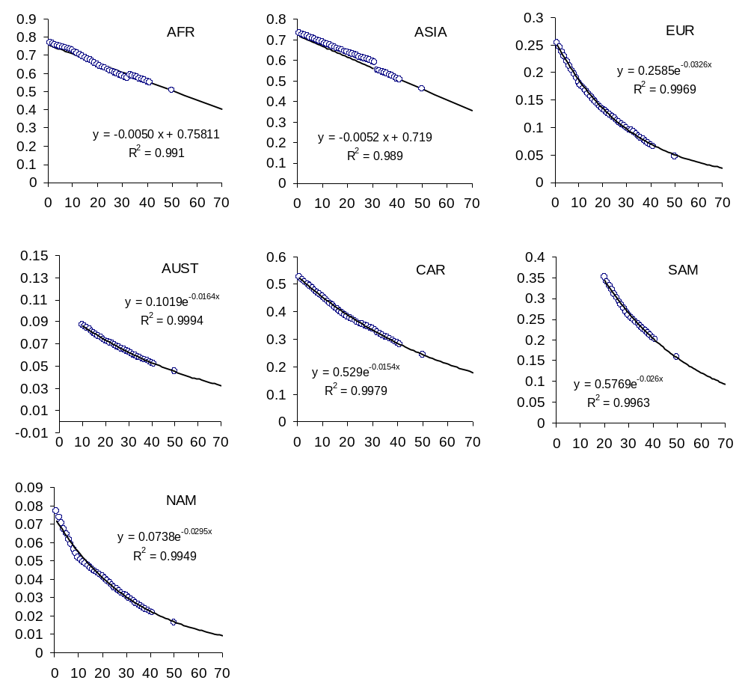

FAO Regions: Eastern Europe (EE), European Union (EU), Com. Ind. States (CI), Near East & North Africa (NE), Indus. Other (OT), East Asia (EA), Baltic states (BA), Latin America (LA), North-America (NA), Oceania (OC), Sub-Saharian Africa (SS), South-Asia (SA).
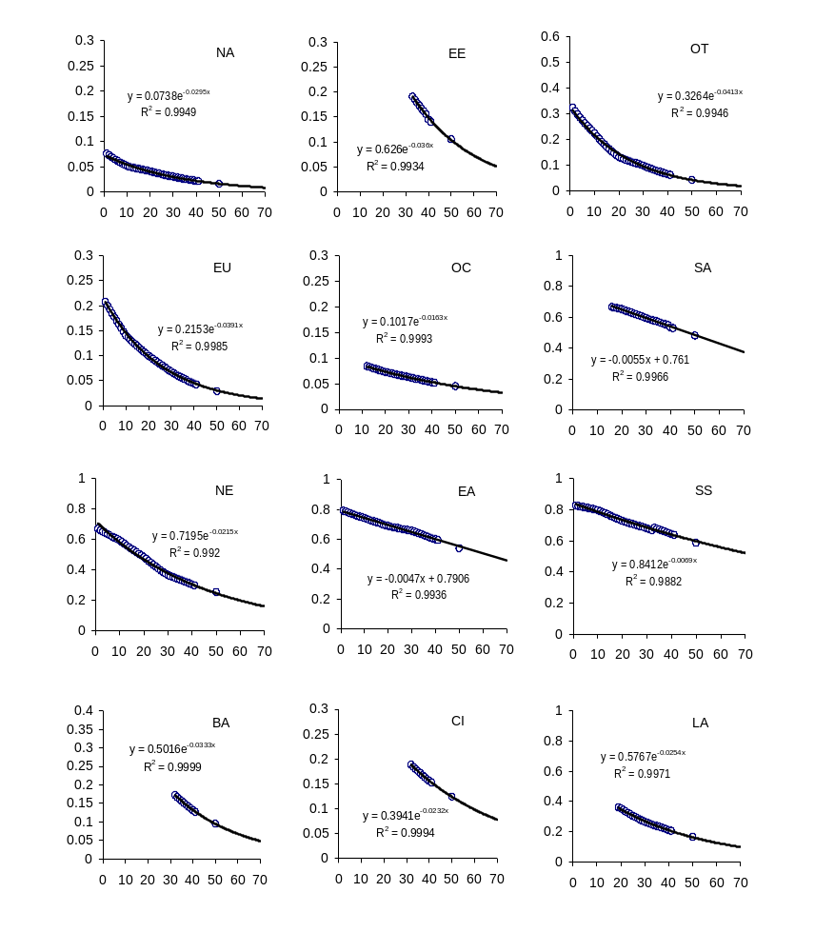

Individual countries
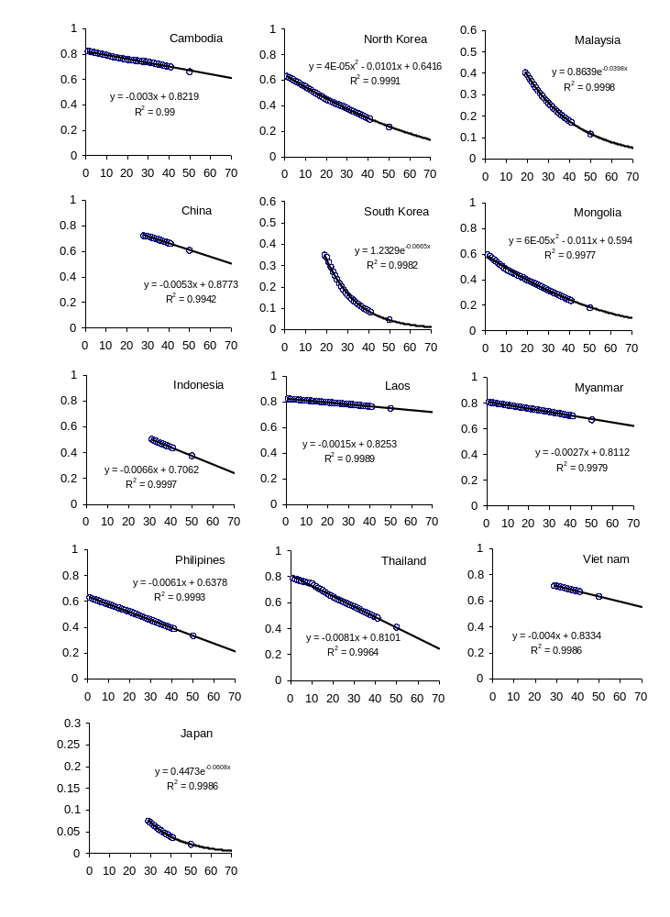

III. Trajectories of OI/AgPop in North-East and South-East Asia.

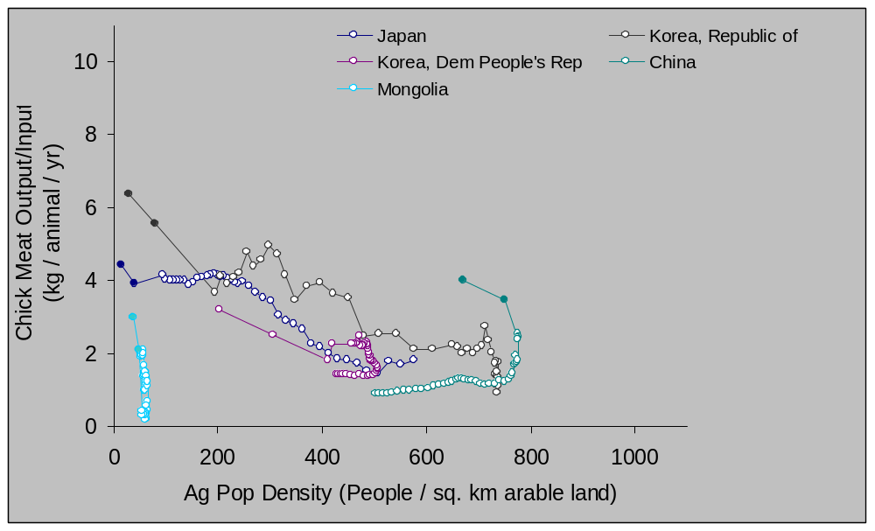

Change in chicken meat output/input and agricultural population density for NorthEast-Asia countries between 1961 and 2001 (empty circles) and predicted for 2015 and 2030 (full circles).

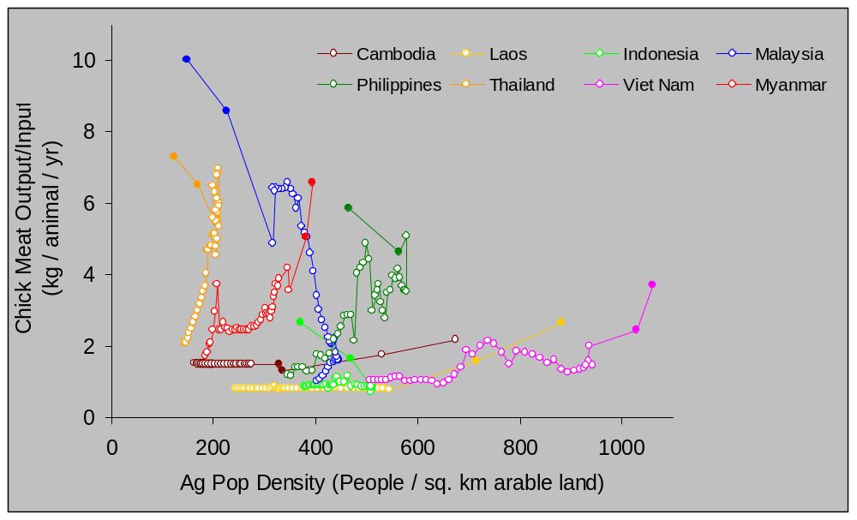

Change in chicken meat output/input and agricultural population density for SouthEast-Asia countries between 1961 and 2001 (empty circles) and predicted for 2015 and 2030 (full circles).
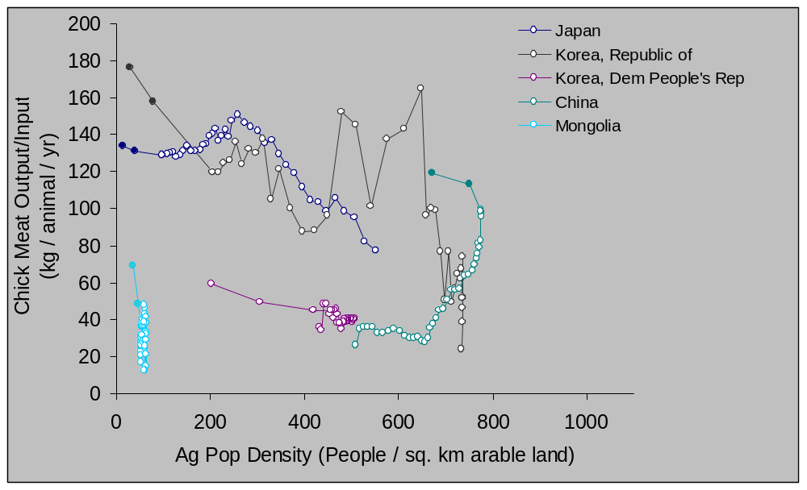

Change in pig meat output/input and agricultural population density for Northeast-Asia countries between 1961 and 2001 (empty circles) and predicted for 2015 and 2030 (full circles).

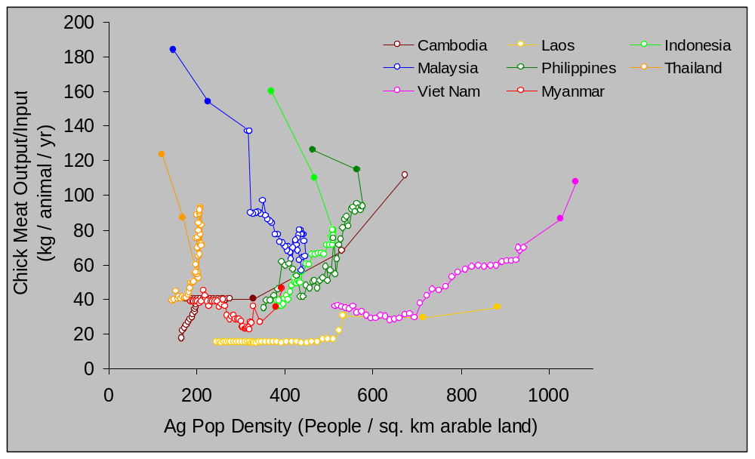

Change in pig meat output/input and agricultural population density for Southeast-Asia countries between 1961 and 2001 (empty circles) and predicted for 2015 and 2030 (full circles).

Organisms can be classified according to their strategies to maximise their fitness: in a predictable environment, it pays to invest resources in long-term development and long life (K-selection) whereas in a risky environment, it is better to produce as much offspring as quickly as possible (r-selection). r-strategists are generally characterised by short generation time, high numbers of offspring and usually have efficient ways of dispersal to new habitats.
In the rest of this text, we will use the term metapopulation defined as a set of host-subpopulations connected by possible microbial traffic
This analysis does not take into account the recent 2004 HPAI outbreaks.
This was tested as an exploratory approach, and when the disease status in the previous time step is entered as predictors, no other variable is left significant in the model.

