MAPPING THE BENEFITS:
FIRST STEPS IN DEVELOPING A NEW DECISION TOOL
FOR TSETSE AND TRYPANOSOMIASIS INTERVENTIONS
Alexandra Shaw¹, Guy Hendrickx² and William Wint³
in collaboration with Victorin Codjia⁴, Rémi Dao⁵, Oumar Diall⁶, Marius Gilbert⁷,
Charles Mahama⁸, Raffaele Mattioli⁹ & Issa Sidibe¹⁰.

¹ A P Consultants, Upper Cottage, Abbotts Ann, Andover, SP11 7BA, United Kingdom
² Avia-GIS, Risschotlei 33, B 2980 Zoersel, Belgium
³ Environmental Research Group Oxford (ERGO), P O Box 346, Oxford, OX1 3QE, United Kingdom
⁴ Direction de l'Elevage, Ministère de l'Agriculture et de la Pêche. BP 2041, Cotonou, Benin
⁵ Insitiut Togolais de Recherche Agronomique (CTRA), BP 114 Sokodé, Togo
⁶ CNRA MDR, B P 2295, Bamako, Mali
⁷ Laboratoire de Biologie animale et cellulaire, C P 160/12, Free University of Brussels, B-1050, Belgium, ⁸ Veterinary Services Department Tsetse and Trypanosomosis Control Unit, P O Box 97, Pongtamale, Ghana, ⁹ AGAH, FAO, Via delle Terme di Caracalla Rome, Italy
¹⁰ CIRDES, 01 B P 454 Bobo-Dioulasso, Burkina Faso

SUMMARY
The purpose of his study was to investigate the feasibility of linking quantitative economic variables to a GIS spatial framework in order to provide new insights and reinforce the decision-making process for tsetse and trypanosomiasis (T & T) interventions. The first phase of the work tackled Benin, Ghana, and Togo; initial data has been collected for parts of Burkina Faso and Mali and will be analysed in the second phase. A range of standardised livestock production and price data were collected at national, province and district level from each country, together with the most recent livestock, cropping and disease data. These were amalgamated with the corresponding data layers from the PAAT Information System and a new distribution map of trypanotolerant and susceptible cattle breeds were produced for the study area. Existing information on the disease’s impact on cattle production parameters were incorporated in herd models. These were used to estimate the potential benefits of T & T interventions for the different cattle breeds, thereby allowing the potential benefits to be mapped as well. The implications for expansions in livestock populations and changes in their distribution are also examined and mapped. A map of the potential benefits for the selected region is presented. The extent to which this approach complements and refines the current range of mapped variables and adds to existing decision-making tools is discussed.

RESUME
L’objectif de cette étude a été d’apprécier la possibilité d’intégrer des variables économiques de type quantitatif dans un SIG et d’estimer le potentiel d’une telle approche pour les prises de décision dans le domaine de la lutte contre les glossines et la trypanosomose. La première phase de cette étude a couvert le Bénin, le Togo, et le Ghana, les données pour une partie du Burkina Faso et du Mali ont déjà été obtenues et seront analysées en deuxième phase. Des données sur la production animale, l’élevage, la santé animale et l’agriculture ont été recueillies dans chaque pays à trois niveaux de résolution géographique: celui du pays, de la province et du canton. Celles-ci ont été combinées avec les couches de données spatiales du système d’information PAAT. Une nouvelle carte de répartition des races bovines trypanotolérantes et susceptibles a été produite pour la zone d’étude. Les informations existantes concernant l’impact de la maladie et les paramètres zootechniques bovins ont été incorporées dans des modèles de troupeaux. Ceux-ci ont été utilisés pour estimer, dans différents races bovines, les avantages potentiels découlant de différents types de lutte contre les glossines et les trypanosomoses, permettant ainsi la mise en carte des avantages économiques potentiels. Les implications de l’expansion et d’une redistribution spatiale éventuelle des populations animales, suite à des activités de lutte, ont également été examinées et mis en carte. Une carte des avantages potentiels est présentée pour la zone couverte par l’étude. Le bénéfice obtenu sur la précision des variables cartographiées est discuté, ainsi que l’impact sur les outils de prises de décision.

INTRODUCTION
Considerable investments have been made by FAO, DFID and the PAAT both in mapping and in other tools for enhancing strategic planning of T & T control. Two key themes have been: the practical applications of GIS for tsetse-trypanosomiasis risk assessment and, more recently, the development of economic guidelines for the identification/selection of T & T intervention areas in West Africa (Hendrickx, 2001, Hendrickx et al., 1997, 2003, Shaw, 2003, Gilbert et al., 2001, Pender et al., 2001). This arose out of a desire to try and combine these approaches, by linking quantitative economic variables to a GIS spatial framework. The first phase of this work - developing the methodology and testing the approach for Benin, Ghana and Togo - has now been completed. The next phase of the work will apply the technique to regions of Burkina Faso and Mali.

MATERIALS AND METHODS
Data Collection
The information upon which this work was based was obtained from a number of published and unpublished sources. First and foremost, data were collected by the national collaborators at three spatial levels. At country level this covered project inventories and censuses, information on tsetse surveys, cattle breed distribution and the existence of rural ‘pioneering fringe’ areas being colonised by graziers and/or farmers. For all administrative level 2 units (provinces or states) data on the number of veterinary outlets and livestock numbers by breed were collected. Finally, for a selection of six administrative level 3 units (districts or ‘cercles’) more detailed data on livestock production systems, livestock input and output prices and seasonal factors was put together, with particular emphasis on the use of work oxen, such as the proportion of households keeping them, hire charges and number of years worked. These data were obtained for Mali and Burkina Faso, as well as for Togo, Benin and Ghana.

Secondly, GIS data were obtained from a number of sources, in particular the PAATIS archive (Pender et al., 2001) which was used for information on cattle population densities (Wint et al., 2002), cropping and vector distributions modelled using remotely sensed variables as predictors (Hay et al., 1999), but modified where necessary by information gathered from the field. Human population data came from Landscan (2002).

Thirdly, information from a number of previous studies was drawn upon. The literature on the impacts of the disease on livestock productivity has been reviewed by Swallow (2000), the studies by Thorpe et al. (1988), Agyemang et al, 1997 and the ground-breaking work by Camus (1981) were particularly helpful. More recent work (e.g. Kamaunga et al. 1999 and 2001) was also consulted. The most comprehensive collections of data on trypanotolerant livestock productivity and distribution are still to be found in three studies: FAO/ILCA/UNEP, 1980, Shaw and Hoste, 1987 and Hoste et al., 1988, which have been complemented by recent work, with a strong socio-economic component, undertaken in West Africa (e.g. CIRDES et al., 2000). Information on cattle carrying capacity was derived in part from Putt et al., 1980, Jahnke, 1982 and Bosma et al., 1996. As the work on this project progresses, more use will be made of grey literature currently being produced in each country studied.

Herd Models
Herd models have been used to evaluate the effects of trypanosomiasis on cattle productivity for over two decades. The first use of these was by Camus (1981), and various models have been used since then to look at the economics of the disease, either in benefit-cost studies, or to evaluate losses in general terms (see Swallow, 2000 for a review of these). The ILCA bio-economic herd model (von Kaufmann et al., 1990) has frequently been used. The model used here differs in several ways: it lacks stochastic elements and direct links to feed resources but does attempt to put a value on draught power and incorporates explicit trypanosomiasis-related features such as the use of trypanocides (Shaw, 1986, 1989, 1994, 2003). The version developed for this study also includes an explicit option to import and export herd cattle and or draught oxen. Modelling this aspect is considered by the authors to be crucial in gaining an understanding of how improved productivity can help to facilitate the geographical expansion of agricultural production systems. The basic structure of the model is as shown in Figure 1.
CORE HERD
(cattle in
the project area)
Cattle ‘Imported’
Fertility, mortality,
milk yield, offtake rates, draught numbers & days worked, prices
Cattle ‘Exported’
Value of milk, draught, animals sold, slaughtered or
exported, less animals import-ed plus change in herd value
Figure. 1 – Structure of the Herd Model

Herd models were built for three breed/production system combinations:
- trypanotolerant taurine cattle production systems with low use of work oxen and moderate effects from disease and moderate trypanocide use (an amalgam of N’dama, savanna and dwarf West African Shorthorn breeds,
- crossbred taurine x zebu cattle production systems with extensive use of work oxen, ubiquitous losses from the disease and use of trypanocides (to include both stabilised crossbreeds such as the Méré and Borgou and more recent crosses between zebu and trypanotolerant breeds)
- and zebu with fewer work oxen and higher trypanocide use and losses from the disease (of which a number of different breeds can also be found in the study area).

It is recognised that these groupings are far from homogenous, showing both wide diversity between trypanotolerant breeds (say between N’dama and Lagune) and between production systems (say between Méré cattle used for draught in the high oxen owning systems of Mali and Burkina Faso and between areas in Togo and Benin where a few crossbred cattle are used for ploughing). However, at this ‘proof of concept’ stage of the work, it was felt that a model based on three, rather than the potential ten or more combinations, was appropriate. Similarly, introducing variation in the model parameters to reflect different levels of tsetse challenge was not done at this stage, and has been reserved for the future.

Assumptions and economic methodology
The herd model was run for twenty years,incorporating a ‘with disease’ and ‘without disease’ projection for each breed/production system grouping. It was assumed that trypanosomiasis was either present or not, so a gradual transition from one state to another was not modelled. Trypanocide use was assumed to fall in the absence of disease, although evidence from the field shows that livestock keepers do not necessarily stop using trypanocides when tsetse are controlled (e.g. CIRDES et al., 2000, Kamuanga et al., 2001). The benefits were calculated as difference between the net present value of output ‘with the disease’ and that ‘without the disease’, over the twenty year period, expressed either per head of cattle present at the start or per head of cattle present at the end of the twenty years in the absence of the disease. The discount rate used throughout was 10%, in line with general practice in livestock projects. Prices used were those for mid-2003. The valuing of output from work oxen was done by using a weighted average of the different hire rates used in the level 3 administrative areas sampled by collaborators. The weights were assigned according to the number of days worked on different tasks. The price used was then adjusted to just over half of the hire rate to reflect the fact that the hire price over-estimates the value and includes a margin of profit for the owner. In order to create a ‘level playing field’ the same prices were used for all models, and were weighted in favour of the three countries reported on here (Togo, Ghana and Benin). Livestock prices tend to decrease further north towards the Sahel and balancing these effects out will be a challenge for the second stage of this study. Other assumptions, for fertility, mortality, offtake, milk yield, days worked by draught males and the impacts of disease on these, were based on the data sources described above. Again, it is recognised that pooling these into three breed/production system groups meant a loss of detail and representativeness for some sub-systems and situations.

RESULTS
Herd Models
The basic results for the three breed/production system combinations modelled were:
- for the trypanotolerant/low work oxen use system, income per head of the herd increased by 23% due to the removal of trypanosomiasis. It was assumed that 50% more of young male cattle were allocated to draught, bringing the proportion of draught males in the herd up from 5% to 7.3% at the end of the 20 years. The annual herd growth rate increased form 1.3% to 2.9% and the net present value of the increased income over 20 years per head of the herd present at the start came to US $150;
- for the crossbred herd, with a high use of work oxen system, income per head increased by 37%. It was assumed that 33% more young male cattle were allocated to draught, so that the proportion of draught males in the herd increased from 15% to 22%. The annual herd growth rate increased from 1.9% to 3.5% and over twenty years the value of the increased income per head of the herd present at the start came to $420;
- for the zebu herd, with fewer work oxen, income per head of the herd increased by 29%. With 50% more young male cattle being allocated to draught work, the proportion of work oxen in the cattle herd increased from 8% to 11%. The annual herd growth rate increased from 2.3% to 4.8% and the net present value of the increased income over twenty years came to $393 per head of the herd present at the start of the period.
These results showed the benefits from controlling the disease to be driven by the presence of work oxen, through their better health and increased numbers. For this reason, the highest benefits were achieved by the crossbred/high oxen use production system, closely followed by the zebus. Due to their being the most susceptible to the disease, its effects on mortality and fertility were consequently the greatest in this group. The trypanotolerant taurine cattle are much less affected by trypanosomiasis and this model contained fewer work oxen, thus leading to the lowest benefit value. In all three production systems, herds were growing, albeit slowly, even in the presence of the disease. This reflects earlier studies (e.g. Camus, 1981) and livestock census data, despite the fact that in the case of serious outbreaks massive losses still occur in susceptible stock (e.g. Kamuanga et al., 2001).

Mapping the dollar benefits from tsetse and trypanosomiasis removal
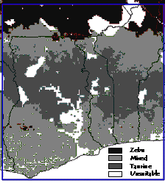
The results of the three breed/production system herd models were then applied to the GIS data. The first step was to produce a predominant cattle breed map using canonical discriminate analysis modelling of training distributions compiled from the field questionnaires for administrative levels 1, 2 and especially from the field questionnaires for level 3. (Figure 2). This illustrates which of the three groups predominates in each area, rather than what proportion of the population is accounted for by each breed. This is the first detailed breed map of this kind produced. As expected, it shows a gradation of trypantolerance, from zebu populations in the north, through a band of crossbred cattle to trypanotolerant stock in the heartlands of Togo, Benin and Ghana. Near the coast where cattle population densities are lower, despite the ubiquitous presence of trypanotolerant stock, the predominant breeds are the zebu x taurine crosses, and in some areas, such as parts of southwestern Ghana, zebus even predominate.
Figure 2: Predicted breed distributions

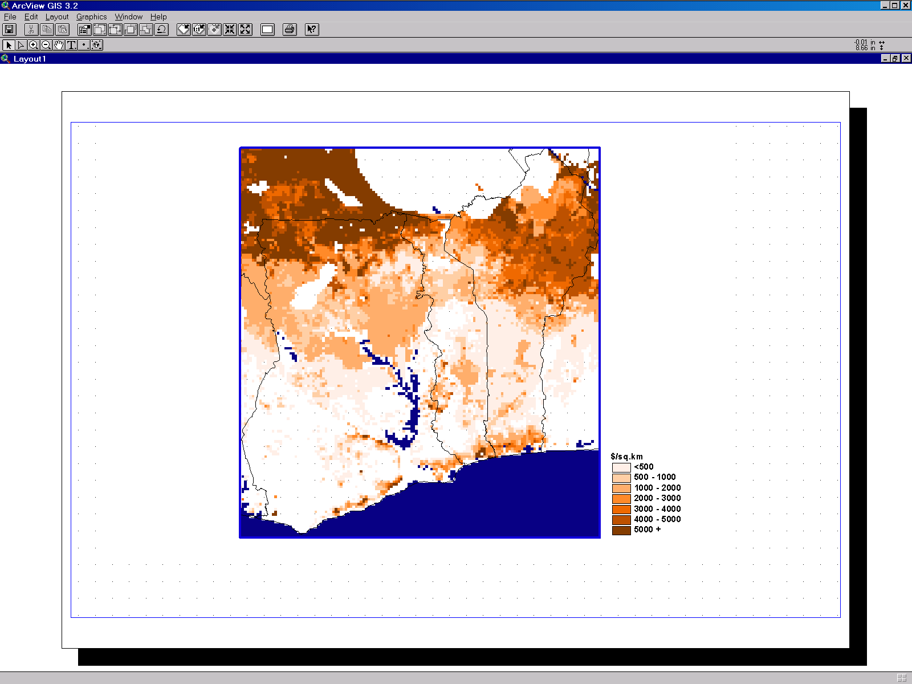
The breed specific dollar values for the benefits from the removal of the disease per head of the herd present at the start of the 20 year period analysed were then applied to a cattle density map taken from the PAATIS archive (Wint et al, 2002; Pender et al, 2001), The result is a first estimate of benefit per square kilometre if the disease were removed, which is then masked by a fly presence layer, also taken from PAATIS, but modified by information derived from the field questionnaires, so that benefits are shown only where flies are currently present. The map produced (Figure 3) is necessarily reminiscent of the cattle population distributions, with greater benefits accruing to areas of high animal density. However, the weighting by breed/production system adds to this by highlighting the areas where susceptible zebu and high oxen use systems are located. The benefits (as described, in the form of a present value discounted over 20 years) ranged from under $500 to well over $5000 per sq km, values which lie within the ranges found in published studies. These figures include not only the outputs of milk, meat and draught, but also a value for the extra cattle present due to the absence of trypanosomiasis. As discussed above, even in the presence of the disease, the cattle populations in the study area are thought to be increasing, which will affect the downstream livestock distributions. However, these growth rates themselves would increase in absence of trypanosomiasis, so that cattle populations at the end of the period would be larger.
Figure 3 – Benefits from trypanosomiasis removal
US $ per sq km per head of cattle present at start of 20 year period

Mapping animal population growth
The elements of cattle population growth have therefore been mapped separately as shown in Figure 4 below and have then been combined in several sequential stages.
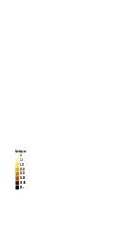
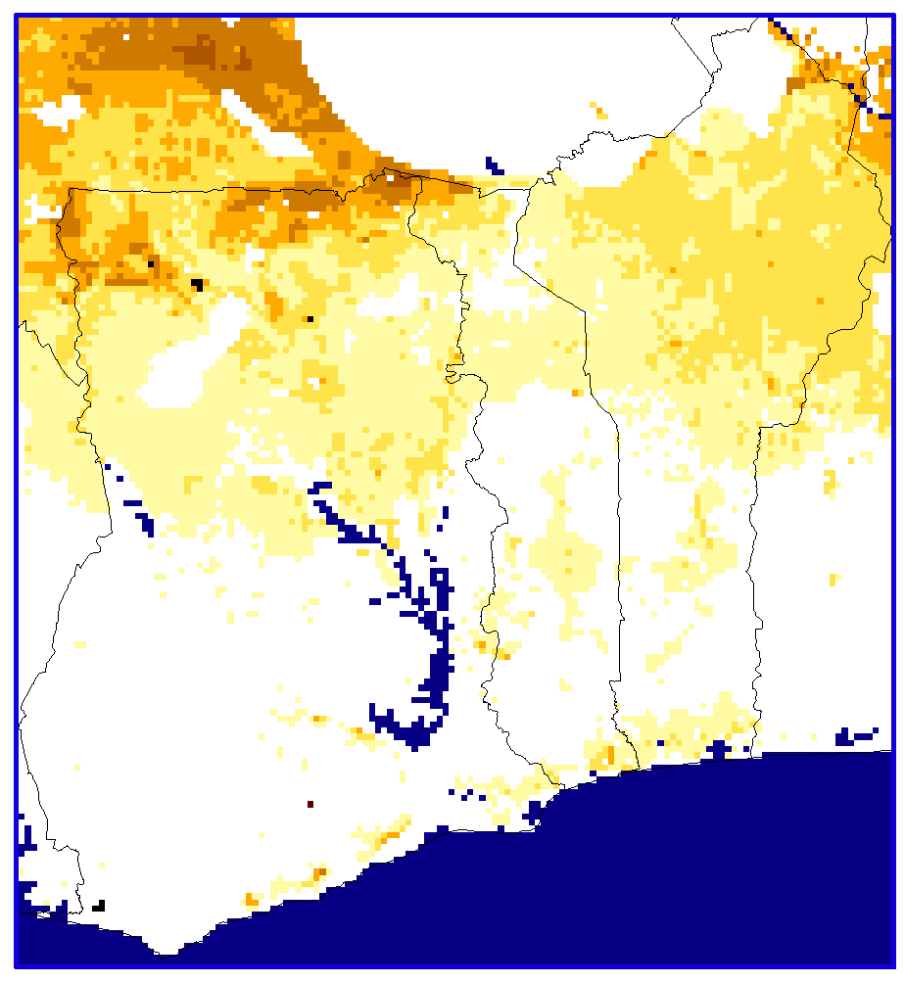
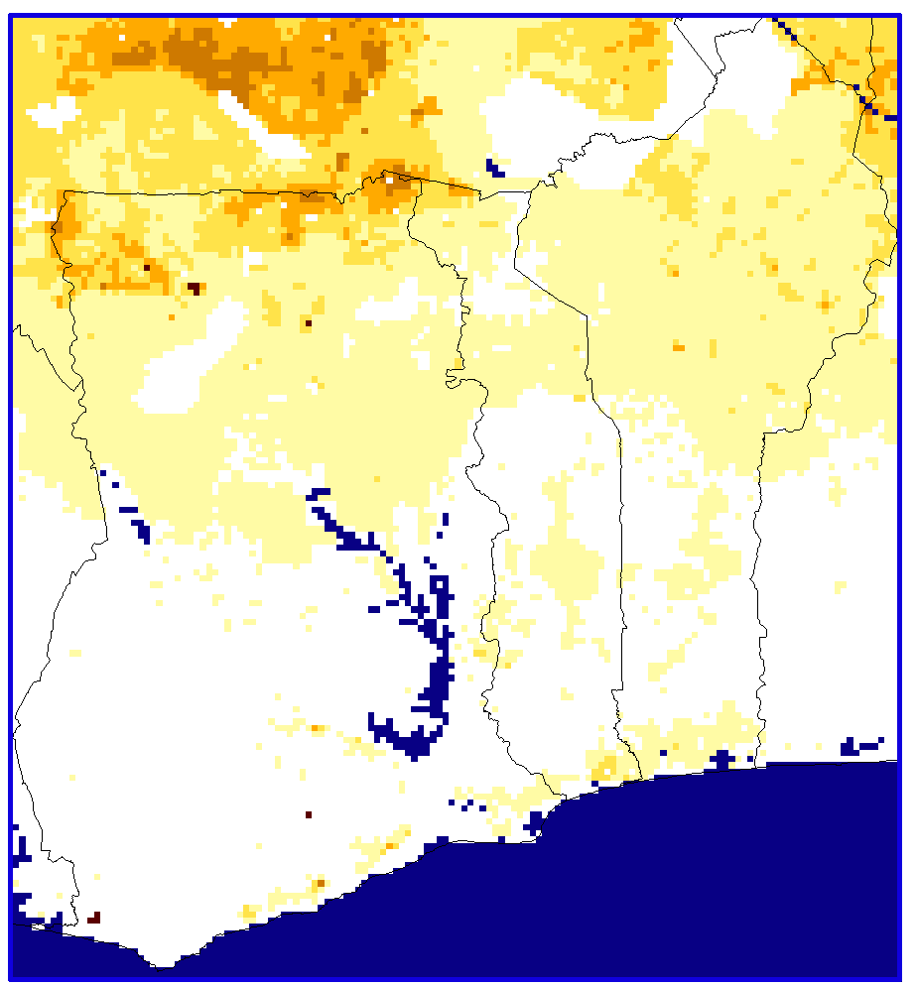
- The breed specific ‘with trypanosomiasis’ growth rates per starting animal are applied to current density maps to give first estimates of livestock growth in the absence of T&T intervention (Figure 4a). When added to the existing population density, the livestock growth maps provide an estimate of the cattle population after twenty years, assuming no T&T interventions.
Figure 4
Growth in cattle density per km² after 20 years
b) Additional growth if no disease
Multiplier increment / head present at start:
Taurine=0.49, Cross=0.69, Zebu=1.05
a) With trypanosomiasis present
Multiplier per head present at start:
Taurine=1.3, Cross=1.46, Zebu=1.6

- Even this first output produces livestock population densities in some foci that significantly exceed likely carrying capacities, and must therefore be adjusted either by reducing calculated densities (equivalent to increasing offtake), or by ‘exporting’ animals from the high concentration areas to surrounding less heavily stocked regions. The second of these possibilities has been adopted here.
- To these redistributed populations, are added the additional increase in cattle numbers due to the removal of the disease as calculated by the models for each breed (shown in Figure 4b).
- Finally, these are redistributed once again to surrounding areas if the nominal carrying capacity is exceeded due to herd growth. These ‘exported’ animals also represent a dollar benefit to those areas into which they are imported, though this is less than that associated with the initial benefits accruing from disease removal. This is because they would only be ‘imported’ to wards the end of the twenty year period being considered, rather than accruing a full twenty years of benefit. This incremental benefit is calculated by using the herd model in the same way, to model the ‘exported’ cattle population from the time of their arrival in the new area to the end of the twenty years being considered for a ‘with’ and ‘without’ disease scenario.
These steps require that carrying capacities are defined and that techniques are developed to assign exported animals to neighbouring areas, each of which are outlined in the following paragraphs.

Mapping Carrying Capacity
Carrying capacity (CC) is a notoriously difficult subject, and has lost credibility amongst many ecologists and environmentalists. Nevertheless, it cannot be assumed that livestock populations can increase without let, and some effort must be made to set density limits beyond which animals must be exported or slaughtered. Many attempts have been made to set these thresholds, amongst which those cited in Jahnke (1982), covering a range of rainfall bands, are widely used, and within the study area can be summarised as CC (in 250 kg Tropical Livestock Units – TLUs) = 0.191annual rainfall +7.6639 (R²=0.998, p<0.001).

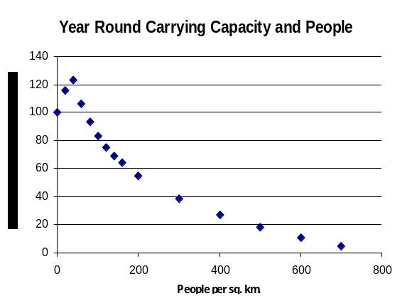
This does not, however incorporate any influence of competing land use by cropping and/or human settlement or the use of crop residues as fodder. Information on the year round carrying capacity in relation to human population density has compiled by Shaw (1986) based on work and studies originally reported on in Putt et al. 1980. Figure 5 expresses these values as a proportion of the carrying capacity at zero population, which has been assumed here to be equivalent to that defined by Jahnke.
Figure 5 – Human population and year round carrying capacity

For current purposes, these estimates had to be converted to cattle population densities, so as to match the units of available livestock density maps. To do this, specific weights were assigned to each cattle breed/production system group, of 0.75 tropical livestock unit (TLU or 250 kgs) for zebu, 0.55TLU for trypanotolerant taurines and 0.705 TLU for crossbreeds.

Mapping Spread
Mechanisms to assign emigrating populations to neighbouring areas from defined foci are still in their infancy. Some rely on simple diffusion, usually density independent, and rely on some function of distance from the point of export to define areas of spread. Others attempt to incorporate an element of stratified dispersal which emulate the establishment of new foci separated from the core areas. A recent set of models (Gilbert 2003, Gilbert et al, 2003) combines both approaches to define sequential areas of spread (‘timestep’), and provides the opportunity to define the rate of spread by diffusion per timestep as well as the number and maximum distance of new foci established by stratified dispersal. It also incorporates the possibility of preventing spread into areas masked by a particular factor (e.g. water or desert), as well as modifying the rate of spread according to a multiplier variable (e.g. suitability or amount of grazing).

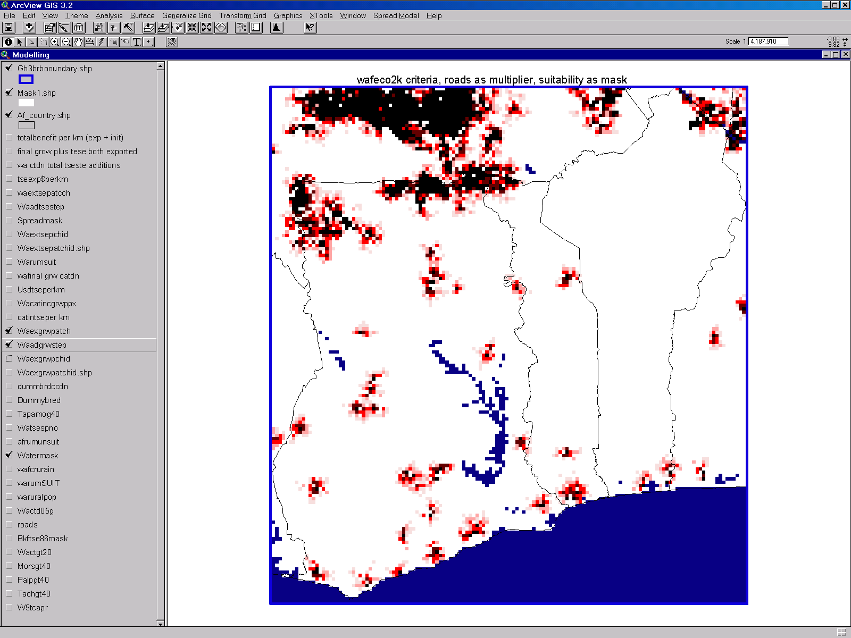
This module thus allows the identification of sequential bands of expansion from known foci (Figure 6) – in the current case, areas of overstocking. Each band or ‘timestep’ is separately coded and can therefore be assigned fixed proportions of the population to be exported. The present analysis defined four timesteps and assigned 40% of the population to be exported from areas defined as overstocked to the first timestep, 30% to the second, 20% to the third and 10% to the fourth and final band. In each case, spread was prevented into areas defined as unsuitable for livestock by FAO (Wint et al., 2003), and was scaled according to proximity to roads (Landscan, 2002) so that movement was less into remoter areas.
Figure 6 Calculated areas of expansion in presence of the disease

Livestock Density Maps
The calculated livestock density after 20 years, if trypanosomiasis is present, is shown in Figure 7a. This forms the base distribution to which the growth due to the removal of the disease can be added, which incorporates a second reallocation of animals from overstocked foci to neighbouring areas once the calculated increases due to the absence of trypanosomiasis have been incorporated. In this second process, ‘export’ has been restricted to areas that have current tsetse fly populations, as these are the only regions from which trypansomiasis can be removed. The spread model criteria for the second export stage were also modified to allow a total movement of 60km over twenty years, as opposed to 15km, on the assumption that a major constraint on livestock expansion was the presence of trypanosomiasis, which had been removed, and that the distance for spread was thus substantially increased. The total increment in population due to the absence of the disease is shown in Figure 7b.

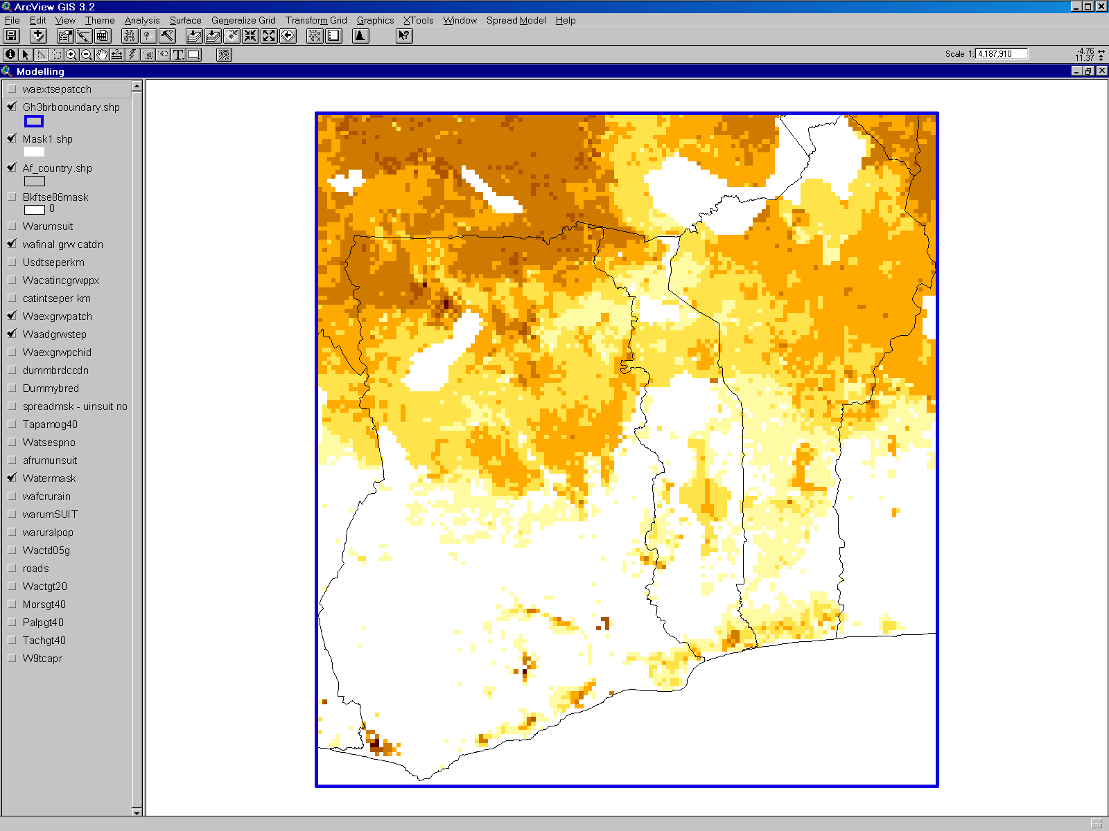
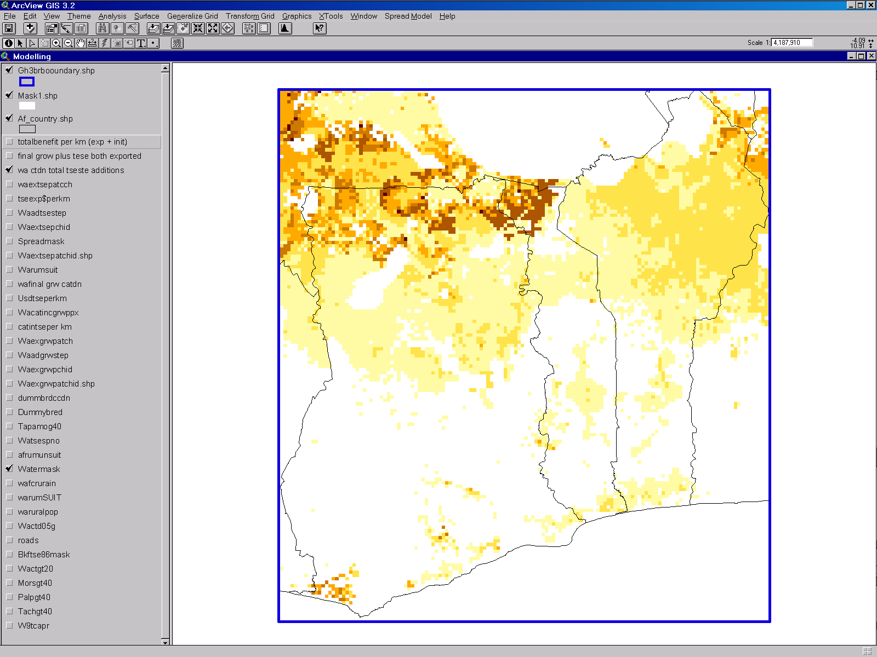
The export of animals following herd growth after intervention may provide an incremental dollar benefit in addition to the direct benefit calculated by the herd models and mapped in Figure 8a. The likely benefits per exported animal are assumed to be lower than the first tranche as the exported stock are assumed not to reach the new areas for some years in the absence of the disease.

Figure 7
a) Cattle density in 20 years, with no intervention
b) Additional growth & spread of cattle in 20 years if trypanosomiasis were absent

The two sets of benefit can be added together to provide a first approximation of the total benefit of removing trypanosomiasis – shown in Figure 8b. This assumes that the initial benefit remains in the areas from which excess animals were exported (and so there is no movement of original owners), but the second incremental one accrues throughout the areas of spread – i.e. new owners are created.

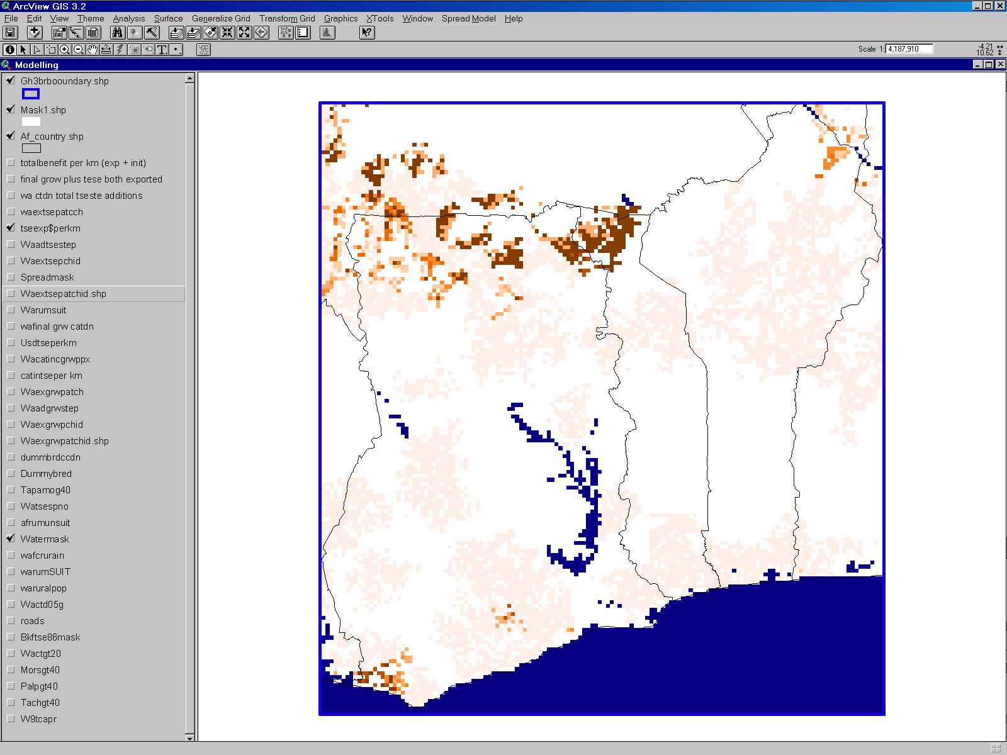
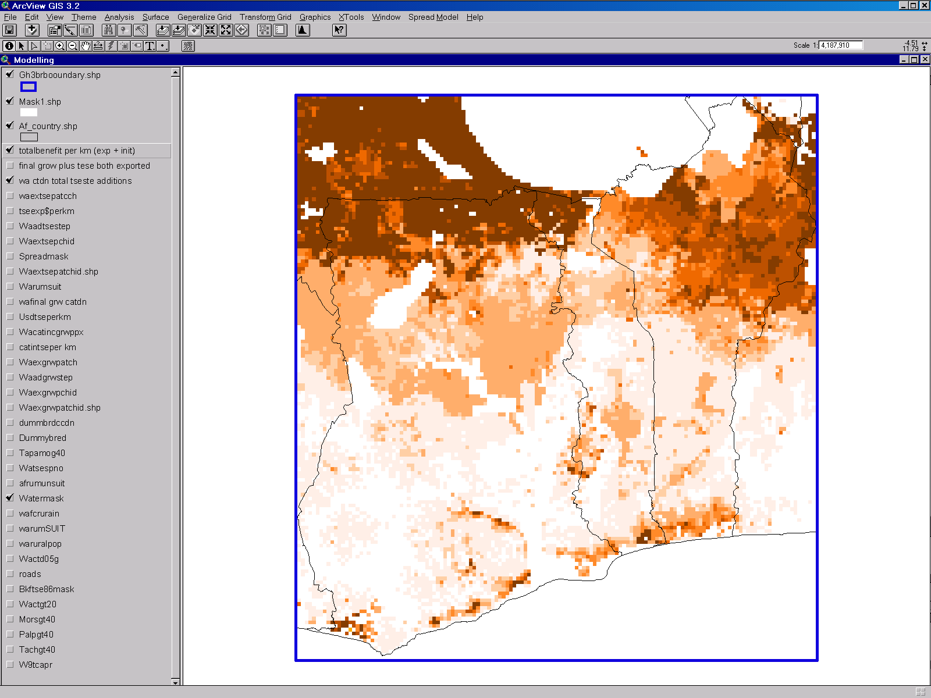
a) From stock reallocated from extra growth if the disease is absent
b) Total in year 20 if the disease were absent
Figure 8 Dollar Benefit per square kilometre
DISCUSSION
This series of maps thus illustrates how introducing the economic dimension, by mapping dollars of benefit per animal, and using a herd model to project cattle populations over time in the absence and presence of disease makes it possible to greatly refine the decision-making process. Although the dollar map for benefits per head of cattle present at the start of a 20 year period (Figure 2) to some extent does reflect the cattle distribution, it nevertheless takes the economic analysis several steps further. Firstly, it shows how weighting the benefits by breed/production system group further refines the picture. Secondly, it produces a $ value per sq km for the benefits. Thus, the ‘proof of concept’ for this method of mapping benefits and its use as a decision tool has been achieved.

However, having demonstrated that it works, some refining and development of this approach still needs to be done. The most important will be producing maps for additional breed/production system combinations. Data for Burkina Faso and Mali have already been collected and this will be analysed and mapped using the methodology described above. At the same time another breed/production system will be defined, based on crossbred cattle and very high use of work oxen as for application to the Burkina/Mali area. The definition of further production systems to mesh with existing farming system data is a further possible step, that needs to be considered in the light of how many systems it is feasible to model or can be supported by data on the effects of the disease on livestock productivity. As mentioned above, the breed maps at the moment are based on the predominant breed, rather than allocating proportions to each breed, and accordingly producing proportionate breed maps is envisaged.

The map showing how the benefits might ‘spread’ as cattle expand into new areas is particularly valuable in showing how the livestock production systems are likely to expand if freed of the constraint of trypansomiasis. This first mapping of the benefits for the ‘exported’ cattle represents an estimate of their value, though it is likely that more disaggregated modelling is needed to produce a range of $ values per exported head of cattle depending on at what point in time they are exported and the uptake levels of draught power in the areas into which they are imported.

It is also important to link the models to levels of tsetse challenge rather than the presence of flies. This would remove the difficulties of evaluating the relative importance of different vector species (ignored in this study) and provide more sensitive results along the limits of vector distributions.

A number of additional factors should eventually be incorporated into these benefit analysis. Of all the livestock species, only cattle have been considered, and the human populations have been assumed to remain static. In addition, no attempt has been made to include, for example, the benefits of removing human sleeping sickness, or the possible costs of livestock growth and spread. There also is still work to be done on the valuing of output from draught oxen and the projection of numbers owned under different scenarios.

Most interesting, and of greatest potential value to decision makers in the field of T & T interventions will be maps of cost as well as benefit. As the outputs are provided for each map pixel, the benefit values could be readily summed for any selected areas of interest, and if compared with potential costs, could produce a cost benefit ratio for any defined area. This would, however, first require a similar exercise to the current one which combines economic cost models with spatial data. The regions which show net benefits at calculated cost levels could then be mapped, as could the cost benefit ratios for the various intervention options. If successful, it may even be feasible to test this approach for other diseases which are endemic over large geographical areas.

ACKNOWLEDGEMENTS
The authors would like to thank the Animal Health Programme of the United Kingdom’s Department for International Development for funding this work, and Prof. Ian Maudlin for his encouragement and support. They also thank Professor Rogers and his TALA Research Group, Oxford University for providing the satellite imagery used to model the vector and livestock distributions.

REFERENCES
Agyemang, K., Dwinger, R. H., Little, D. A. and Rowlands G. J. (1997) Village N’dama Cattle Production in West Africa: Six years of research in The Gambia. International Research Institute, Nairobi, Kenya and International Trypanotolerance Centre, Banjul, The Gambia. 131 pp.
Bosma, R., Bengaly, K., Traoré, M. and Roelveld, A. (1996) L’élevage en voie d’intensification. Institut Royal des Tropiques, The Netherlands and Institut d’Economie Rurale, Mali, 202 pp.
Camus, E. (1981) Evaluation économique des pertes provoquées par la trypanosomose sur quatre types génétiques de bovins dans le nord de la Côte d’Ivoire. Revue d’Elevage et de Médecine vétérinarie des Pays tropicaux 34, 297-300.
Centre International de Recherche-Développement sur l’Elevage en Zone Subhumide (CIRDES), International Livestock Research Institute (ILRI) and the International Trypanotolerance Centre (ITC) (2000) Joint report of accomplishments and results (1993-1999). Collaborative Research Programme on Trypanosomosis and Trypanotolerant Livestock in West Africa, funded by the Commission of the European Communities. 227 pp.
FAO, ILCA and UNEP (1980) Trypanotolerant Livestock Development in West and Central Africa. Vol. I – General Study, Vol. II – Country Studies. FAO Animal Production and Health Papers 20/1 and 20/2, FAO, Rome, 146 pp. and 303 pp.
Gilbert, M. (2003) Environmental health management: Training module on spatial epidemiology. Consultancy report prepared for the Animal Health Service, FAO, Rome.
Gilbert, M., Jenner, C., Pender, J., Rogers, D., Slingenbergh, J. and Wint, W. (2001) The Programme Against African Trypanosomiasis Information System (PAATIS) In: Black, S. N. and Seed, J. R. (eds) World Class Parasites: Volume 1 – The African Trypanosomes. Kluwer Academic Publishers, Dordrecht, The Netherlands, pp.11-24
Gilbert, M., Grégoire, J,-C, Freise, J.F., & Heitland, W, (2003) Long-distance dispersal and human population density allow predicting the invasion of the horse-chestnut leafminer Cameraria ohridella.
Hay, S. I. and Lennon, J. J. (1999). Deriving meteorological variables across Africa for the study and control of vector-borne disease: a comparison of remote sensing and spatial interpolation of climate. Tropical Medicine and International Health, 4(1) 58-71.
Hendrickx, G. (2001) Practical application of GIS for the identification and selection of control areas in West Africa. Lead paper presented at the FAO/IAEA Workshop “Strategic Planning of Area-Wide Tsetse and Trypanosomosis Control in West Africa” Ouagadougou, Burkina Faso, from 21 to 24 May 2001, 22 pp.
Hendrickx G., Slinghenbergh, J. H. W., Dao, B., Bastiansen, P. and Napala A. (1997) Geographic Information Systems (GIS), Powerful Tools in Decision Making. In: Publication no. 119, ISCTRC, 24th Meeting: Maputo, Mozambique, 1997, published 1999, OAU/STRC, Nairobi, Kenya, pp. 464-471.
Hendrickx, G., de La Roque, S. and Mattioli, R. (2003). Long-term tsetse and trypanosomiasis management options in West Africa. PAAT Technical and Scientific Series, FAO, Rome (in press).
Hoste, C. H., Chalon, E., d’Ieteren, G. and Trail, J. C. M. (1988) Le bétail trypanotolérant en Afrique occidentale et centrale – Vol. 3 – Bilan d’une décennie. FAO Animal Production and Health Studies 20/3, FAO, Rome, 281 pp.
Jahnke H.E (1982) Livestock Production Systems and Livestock Development in Tropical Africa" Kieler Wisenschaftsverlag Vauk, Kiel, Germany, 253 pp.
Kamuanga M., d’Ieteren, G., Tano, K., Jabbar, M. A., Swallow, B. M. and Pokou, K. (1999) Farmer preferences of cattle breeds, their market values and prospects for improvement in West Africa: A summary review of case studies in Burkina Faso, Côte d’Ivoire and Nigeria. In: Proceedings of the 25th Meeting of the ISCTRC Mombasa, Publication no. 120. OAU/STRC, Nairobi, pp. 271 – 289.
Kamuanga, M., Sigué, H., Bauer, B., Swallow, B. and d’Ieteren, G. (2001) Farmers’ Perceptions of the Impacts of Tsetse and Trypanosomosis and Control on Livestock Production: Evidence from Southern Burkina Faso. Tropical Animal Health and Production 33, 141-153.
von Kaufmann, R., MacIntyre, J. and Itty, P. (1990) ILCA bio-economic herd model for micro-computer. Technical Reference Guide. ILCA, Addis Ababa, Ethiopia.
Landscan (2002) The LANDSCAN dataset is produced and distributed by Columbia University’s Oak Ridge National Laboratories. http://sedac.ciesin.columbia.edu/plue/gpw/landscan/
Pender, J., Jenner, C., Wint, W. and Gilbert, M. (2001) Programme against Animal Trypanosomiasis Information System (PAATIS). Software Website and data CD produced by Environmental Research Group Oxford Ltd on behalf of the Natural Resources Institute, Chatham, for the Food and Agriculture Organisation, Rome and the Department for International Development, London. http://www.fao.org/paat/html/home.htm.
Putt, S. N. H., Shaw, A. P. M., Matthewman, R. W., Bourn D. M., Underwood, M., James, A. D., Hallam, M. J. And Ellis, P. R. (1980) The Social and Economic Implications of Trypanosomiasis Control - a study of its impact on livestock production and rural development in northern Nigeria. Veterinary Epidemiology and Economics Research Unit, Study no. 25, Reading University, 549 pp.
Shaw, A. P. M. (1986) The control of Trypanosomiasis in the Sudan and Northern Guinea Zones of West Africa, with special reference to Nigeria and Mali. PhD thesis, University of Reading, 338 pp.
Shaw, A. P. M. (1989) The Use of Mathematical Models in Estimating the Potential Economic Benefits of Trypanosomiasis Control. In: Publication no. 115, ISCTRC, 20th Meeting: Mombasa, Kenya, 1989, published 1991, OAU/STRC, Nairobi, Kenya, pp. 106-114.
Shaw, A. P. M. (2003) Economic Guidelines for Strategic Planning of Tsetse and Trypanosomiasis Control in West Africa. FAO Programme Against African Trypanosomiasis (PAAT) Position Paper (in press).
Shaw, A. P. M. and Hoste, C. H. (1987) Trypanotolerant Cattle and Livestock Development in West and Central Africa. Vol. I - The international supply and demand for breeding stock, Vol. II – Trypanotolerant cattle in the national livestock economies. FAO Animal Production and Health Papers 67/1 and 67/2, FAO, Rome, pp. 184 and pp. 330.
Shaw, A. P. M., Zessin, K. H. and Münstermann, S. (1994) Modelling the economics of tsetse control using mono-pyramidal traps in Côte d’Ivoire. In: Rowland, G. J., Kyule, M. and Perry, B. D. (eds.) Proceedings of the 7th International Symposium on Veterinary Epidemiology and Economics, Nairobi, Kenya. The Kenya Veterinarian 18, 244-246.
Swallow, B. M. (2000) Impacts of Trypanosomiasis on African Agriculture. PAAT Technical and Scientific Series 2, FAO, Rome. 52 pp.
Thorpe, W., Coulibaly, L., Defly, A., d’Ieteren, G. D. M., Feron, A., Grundler, G., Hecker, P., Itty, P., Maehl, J. H. H., Mawuena, K., Mokramer, G., Mulungu, M., Ngada, S. M., Paling, R. W., Pelo, M., Rarieya, J. M., Shuetterle, A., and Trail, J. C. M. (1988) Factors influencing reproductive performance in a range of Network situations. In: African Trypanotolerant Livestock Network (ATLN) Livestock Production in Tsetse Affected Areas of Africa. ILCA/ILRAD, Nairobi, Kenya, pp. 210-217.
Wint, W., Bourn D., Hendrickx, G., Kruska, R., and Slingenbergh, J et al (2002) Livestock Mapping: Present and Future. Chapter 2 in: Tateishi, R. and Hastings, D. (eds) Global Environmental Databases (Volume 2). International Society for Photogrammetry and Remote Sensing (ISPRS), pp. 39-54.
Wint, W., Chilonda, P., Gerber, P., Robinson, T. and Wassenaar, T. (2003) Defining Land Unsuitable for Livestock. Consultancy Report prepared by Environmental Research Group Oxford Ltd for the Animal Health Service of the Animal Production and Health Division of the Food and Agriculture Organisation of the United Nations, Rome, Italy.

